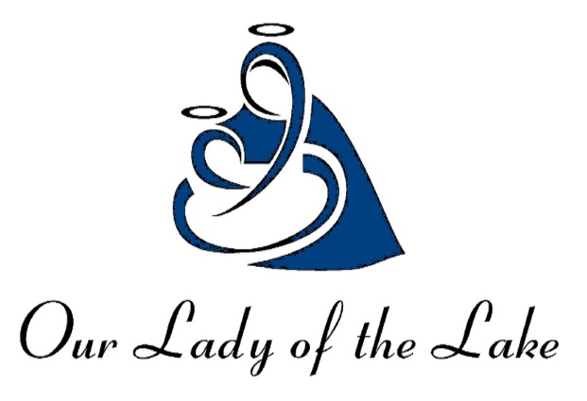
Our Lady of the Lake Church
Our Lady of the Lake Regional Catholic School
1037 West Houghton Lake Drive ~ PO Box 800
Prudenville, MI 48651

WE ARE IN THIS TOGETHER
Dear Parishioners,
It has been about fourteen weeks since we reopened our church doors for public Masses and other Liturgical celebrations. I sincerely appreciate your understanding, sacrifice, and support during all this. Our church doors can only remain open if we continue to follow CDC, State, and Diocesan guidelines and protocols.
On Tuesday, August 25th, our School, Our Lady of the Lake Regional Catholic School reopened her doors for the 2020/2021 school year for in-person instruction. Thanks to all who contributed in guiding and helping our school principal Michelle Johnson, teachers and staff in the preparation for reopening. Let’s continue to keep the school and parish in our prayers as we navigate through these unchartered waters.
At the beginning of the last school year, faculty and staff chose a theme to guide their steps and those of the students throughout the school year. Last year’s theme was “212 degrees”. This idea was a valuable lesson taken from the book “212° The Extra Degree” by Sam Parker and Mac Anderson. The premise of the book is based on the analogy that at 211 degrees, water is very hot. At 212 degrees, it boils, and with boiling water, comes steam, and steam can power a train. So, raising the temperature by one degree is the difference between something being very hot, and something that generates enough force to power a massive machine. This is a great and simple metaphor that the school used to feed all of her endeavors. Staff, faculty and students were encouraged to consistently push themselves to make the extra effort in all their tasks; a reminder that even small things can make a huge difference.
For this academic year, with its challenges and blessings, the school has chosen the theme “We can move mountains.” The year 2020 has thrown a curveball to all humanity. However, together we can overcome. Love of self and neighbor includes wearing face masks, regularly washing hands, keeping six-foot social distancing, extra cleaning and sanitizing, and many others.
Church Building and Repairs: Last year we signed a contract with a local contractor for repairs on the water leaks and other ancillary damages to our buildings. However, with the Covid-19 lockdown work has been delayed. We recently received a commitment from the company that work on the repairs will begin on or before October 1, 2020. Plumbing work will begin as soon as we are able to secure a contractor. After the leaks are fixed and repaired, work will begin on drywall areas to repair water damage.
Church and School Building Cleaning: With the COVID-19, we are faced with the ‘new normal’, extra cleaning and sanitizing. The Church is thoroughly cleaned and sanitized before and after Saturday and Sunday Mass with the Tornado Vapor Mist which was recently purchased. This will also come in handy for school cleaning and sanitizing.
Sunday Mass Dispensation Extended: Bishop Hurley, the Apostolic Administrator, announced the extension of the dispensation for all Catholics within the Diocese of Gaylord from the obligation of attending Sunday Mass through and including the feast of Christ the King, Sunday, November 22, 2020. People in the at-risk groups are encouraged to stay home. Watch past or present Live-Streamed Masses
via Youtube. To view live-streamed Masses, go to Youtube.com, type OLL (month day) into the search bar at the top of the page (example: “OLL830” will bring up the Mass from August 30th). You can then watch the recording by left clicking on it. You can attend Mass during the week (Tuesday thru Friday at 9AM).

Great thanks to Art Gonzalez and Noah Sandoval, who are helping the parish in the Mass live-streaming apostolate.

Catholic Services Appeal (CSA) drive has been going well. However, we are yet to reach our target of $43, 141.00 which is 20% less than our normal year target. Thank you to all our parishioners who have made their gift to the 2020 Catholic Service Appeal. If you have not yet made a gift or pledge, it is not too late to help us meet and even exceed our target. Every gift, regardless of the size, is vital to the success of the Appeal, so please be as generous as possible. Together, we can move mountains.
2020 COVID-19 Catholic Educational Relief Fundraiser: Because of COVID-19, our typical school fundraising drives have been cancelled. Money raised through these events fund 25% of the school’s operating budget. In lieu of our traditional school fundraisers, OLLRCS is sponsoring a fundraising sponsorship/donation campaign to help support our school. You may have received a letter regarding this fund drive. We are encouraging those who can to please continue to support our school. We are hoping and praying that you will help us make this campaign a success in this difficult time.
Sacrament of Reconciliation/Confessions are available every Friday, 10am to 11am or by appointment.
New Parish and School Website: We were able to launch a new parish and school website at no cost thanks to the various businesses that place ads at the back of our parish bulletin. Because of their ads we receive weekly bulletins, websites, MYParish app, and weekly shipment of bulletins at no cost to both the parish and the school through Diocesan Publications. Weekly bulletins are available on the parish website or through MyParish App.
Extra Ordinary Ministers of Holy Communion recertification will not take place this year due to Covid-19. All Extra Ordinary Ministers may continue ministering as is until further notice.
Parish Support: Thank you for your continued support to our parish during these difficult times. The Parish and school must meet salary obligations, pay for utilities and other necessities. Thanks again, we depend on your prayers and generosity to meet our pastoral obligations. Offertory contributions may be placed in the collection baskets at Mass, mailed in or submitted through MyParish app for weekly donations, school donations and CSA contributions.
In these unprecedented and uncertain times, we are confronted once more with the fragility of our lives. Despite all the sufferings and difficulties, we must always run to God, because he is love. God does not abandon us; God goes with us, even now in this time of trial and testing. In this moment, it is important for us to anchor our hearts in the hope that we have in Jesus Christ.
Jesus experienced the full measure of human suffering. The Lord suffered and died for us and for our salvation, and, no matter what befalls us, be it sickness or tribulations, our hope in Jesus’ love will not disappoint us. We will find the grace to join our sufferings to Jesus’, and as we do so, we will come to realize something of the depth and beauty of God’s love for us.
If you have not had the opportunity to join us in person for the Public Masses, please know that you are in our thoughts and prayers. Let’s continue to hold one another up in prayers as we follow the good Lord, each day of our lives.
Know that you are loved,

Fr. Peter

