December | 2020

Our Lady of the Lake Catholic Church
Sunday | Monday | Tuesday | Wednesday | Thursday | Friday | Saturday
 |  | 1 | 2 | 3 | 4 | 5
 |  | 9:00 am Mass | 9:00 am Mass | 9:00 am Mass | First Friday Adoration  9:00 am Mass  Confessions  10:00 – 11:00 am | First Saturday  9:00 am Mass  Confession 3 pm  4:00 pm Mass
6 | 7 | 8 | 9 | 10 | 11 | 12
Confession 8 am  9:00 am Mass | No Mass  Faith Formation  3:30 – 5:00  Cafeteria | 9:00 am Mass  6:30 pm Mass  Immaculate Conception | 9:00 am Mass | 9:00 am Mass | 9:00 am Mass  Confessions  10:00 – 11:00 am | Confession 3 pm  4:00 pm Mass  Scrip Cards  (after Mass)
13 | 14 | 15 | 16 | 17 | 18 | 19
Confession 8 am  9:00 am Mass  Scrip Cards  (after Mass) | No Mass | 9:00 am Mass | 9:00 am Mass  Advent Play | 9:00 am Mass | 9:00 am Mass  Confessions  10:00 – 11:00 am | Confession 3 pm  4:00 pm Mass  Scrip Cards-  (after Mass)
20 | 21 | 22 | 23 | 24 | 25 | 26
Confession 8 am  9:00 am Mass  Scrip Cards  (after Mass) | No Mass | 9:00 am Mass | 9:00 am Mass | 4:00 pm Mass  Christmas Vigil | 9:00 am Mass  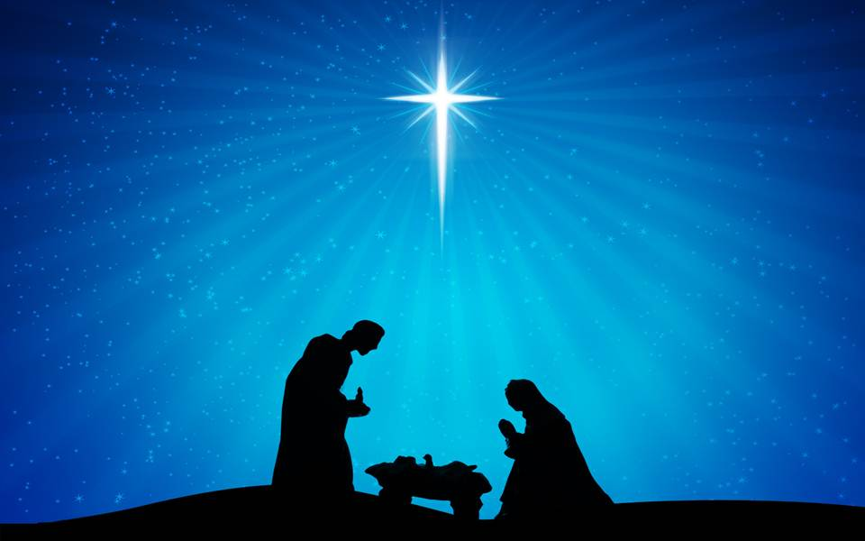  Christmas | 4:00 pm Mass  St. Vincent de  Paul Collection
27 | 28 | 29 | 30 | 31
9:00 am Mass  St. Vincent de Paul Collection | No Mass | 9:00 am Mass | 9:00 am Mass | New Year’s Eve  4:00 pm Mass
***The Parish/School office will be closed during the Holiday Break December 20, 2020 – January 1, 2021.
Regular Office hours are Monday – Friday 8:00 am – 4:00 pm.
Weekend Masses and the Feast of the Immaculate Conception will be live-streamed. To view, go to YouTube.com, type OLL(month day) into the search bar at the top of the page. Example: “ OLL621 ” would bring up the Mass from June 21st, you can then watch it by left clicking on it.
If you need to reach Father Peter after hours, call the church office and dial Ext. 112
**All OLLRCS Alumni are encouraged to join the alumni Facebook group. Simply enter Our Lady of the Lake School Alumni Group in the Facebook search window.

