May | 2021

Our Lady of the Lake Catholic Church
Sunday | Monday | Tuesday | Wednesday | Thursday | Friday | Saturday
 |  |  |  |  |  | 1
First Saturday Mass
9:00 am

4:00 pm Mass
2 | 3 | 4 | 5 | 6 | 7 | 8
9:00 am Mass  Youth Ministry  10:00-11:30 am  May Crowning  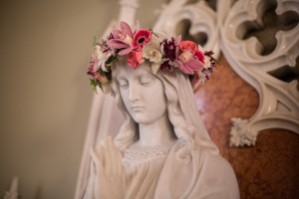 | No Mass  Open Registration  (Parish Families) | 9:00 am Mass | 9:00 am Mass  School May Crowning | 9:00 am Mass | 9:00 am Mass  First Friday Adoration | 4:00 pm Mass
9 | 10 | 11 | 12 | 13 | 14 | 15
9:00 am Mass  Mother’s Day | No Mass | 9:00 am Mass | 9:00 am Mass | 9:00 am Mass | 9:00 am Mass | 4:00 pm Mass
16 | 17 | 18 | 19 | 20 | 21 | 22
9:00 am Mass  Youth Ministry  10:00-11:30 am  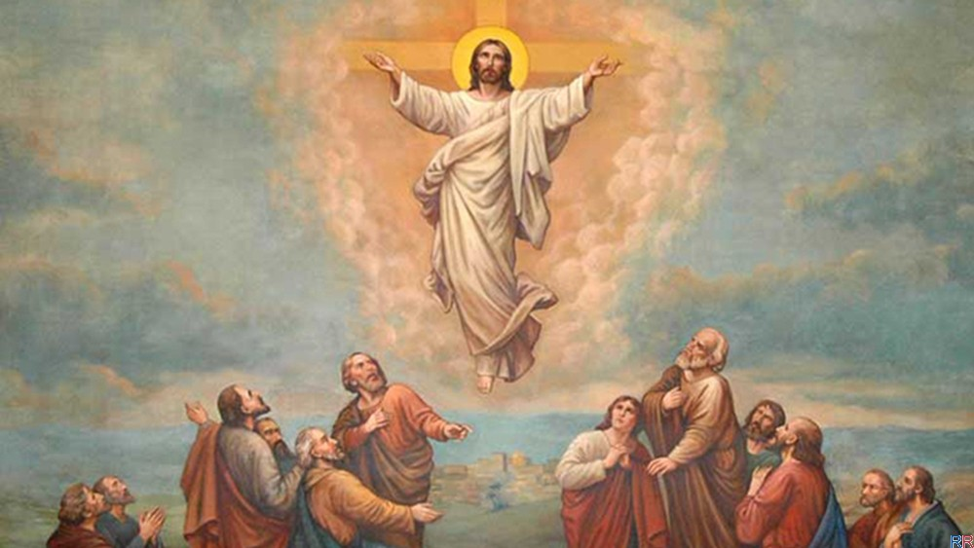 | No Mass  CCW  6:00 pm | 9:00 am Mass | 9:00 am Mass | 9: 00 am Mass | 9:00 am Mass | 4:00 pm Mass
23 | 24 | 25 | 26 | 27 | 28 | 29
9:00 am Mass | No Mass | 9:00 am Mass | 9:00 am Mass | 9:00 am Mass | 9:00 am Mass | 4:00 pm Mass  St. Vincent  Collection
30 | 31
9:00 am Mass  St. Vincent  Collection | 9:00 am Mass  Memorial Day  Office Closed
Parish/School Office Hours: Monday – Friday 8:00 am – 4:00 pm.
If you need to reach Father Peter after hours, call the church office and dial Ext. 2
Mass Cancellations: If Our Lady of the Lake Regional Catholic School is closed due to inclement weather, daily Mass is cancelled.
Weekend Masses will be live-streamed. To view, go to YouTube.com, type OLL(month day) into the search bar at the top of the page. Example: “ OLL621 ” would bring up the Mass from June 21st, you can then watch it by left clicking on it.

