ALL SOULS DAY MEMORIAL CANDLE: November is a month we pray for the dead. All Saints’ Day, November 1, is the day we celebrate those in heaven. All Souls’ Day, November 2, is the day we pray for the dead. On this special day, we light candles for our family and friends who have died. Each candle stands for someone special in our lives who has passed. This year we will have the opportunity to commemorate the faithful departed by lighting a candle in their memory on:
Tuesday, November 2, 2021
at the 6:00 pm Mass

The personalized candle will be blessed at Mass. At the end of Mass, the owner can either take the candle(s) home or leave it in the church where it will continue to burn for several days.

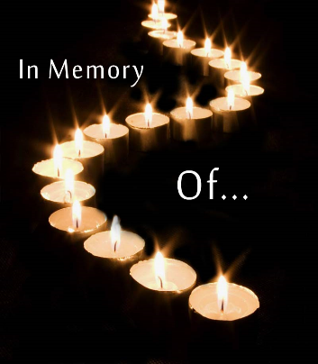
Each candle will be personally labeled, “In loving Memory of ________________________.” You may order a candle in the name of a spouse, mother, father, brother, sister, cousin, grandparent, father and/or mother-in-law, child, aborted baby, or for anyone else who has touched your life and has since passed on. If you would like to order a candle, please complete the form below.

MEMORIAL CANDLE ORDER FORM

REQUESTED BY: ___________________________________________
PHONE NUMBER: __________________________________________

NAME(S) OF THE DECEASED: (please print clearly)

1______________________________________ 5______________________________________
2______________________________________ 6______________________________________
3______________________________________ 7______________________________________
4______________________________________ 8______________________________________
TOTAL NO. OF CANDLES ORDERED: _____ x $3.00/each = TOTAL AMOUNT ENCLOSED: $____________
Mail completed form with full payment to Parish/School office or place in collection basket at Mass no later than October 19, 2021. Checks can be made payable to OLL.

