October | 2021

Our Lady of the Lake Catholic Church
Sunday | Monday | Tuesday | Wednesday | Thursday | Friday | Saturday
 |  |  |  |  | 1 | 2
 |  |  |  |  | First Friday Adoration  9:00 am Mass | First Saturday  9:00 am Mass  Confessions 3:00pm  4:00 pm Mass
3 | 4 | 5 | 6 | 7 | 8 | 9
Confessions  8:00am  9:00 am Mass  Faith formation 9:00am-11:00am  Blessing of Pets  11:00am | No Mass | 9:00 am Mass | 9:00 am Mass | 9:00 am Mass | 9:00 am Mass | Confessions 3:00pm  4:00 pm Mass
10 | 11 | 12 | 13 | 14 | 15 | 16
Confessions  8:00am  9:00 am Mass  Youth Group  10:00-11.30 | No Mass | 9:00 am Mass | 9:00 am Mass | 9:00 am Mass  Mass at the Brook  11:00 | 9:00 am Mass | Rosary Rally  12:00pm  Confessions 3:00pm  4:00 pm Mass
17 | 18 | 19 | 20 | 21 | 22 | 23
Confessions  8:00am  9:00 am Mass  Faith formation 9:00am-11:00am | No Mass  CCW Meeting  3:45 Pm | 9:00 am Mass | 9:00 am Mass | No Mass | No Mass | Confessions 3:00pm  4:00 pm Mass
24 | 25 | 26 | 27 | 28 | 29 | 30
Confessions  8:00am  9:00 am Mass  Youth Group  10:00-11.30 | No Mass | No Mass | 9:00 am Mass | 9:00 am Mass | 9:00 am Mass | Confessions 3:00pm  4:00 pm Mass  St. Vincent de Paul Collection
31 | November 1 1 | November 2
Confessions  8:00am  9:00 am Mass  St. Vincent de Paul Collection | All Saints Day  Mass 9:00am  Mass 6:00pm | All Souls Day  Mass 9:00am  Candle Blessing 6:00 pm
Parish/School Office Hours: Monday – Friday 8:00 am – 4:00 pm.
If you need to reach Father Peter after hours, call the church office and dial Ext. 112

October Birthdays

October 25 Gary Chapp
October 26 Helen Schrank
October 28 Charlotte Sredzinski
Mary Stuck
October 29 Madison Speer
October 30 Marion Post
October 31 Haleigh Foster
Mark Giasson
Patrick Torres

October 2 George Everett
Allison Hood
October 5 Michael Mackey
Carol Spindler
October 7 Laurie Chudzinski
Timothy Cowan
Tyler Silva
October 8 Edmund Lipon
October 10 Michael Beech
Barbara Parol
Mary Speer
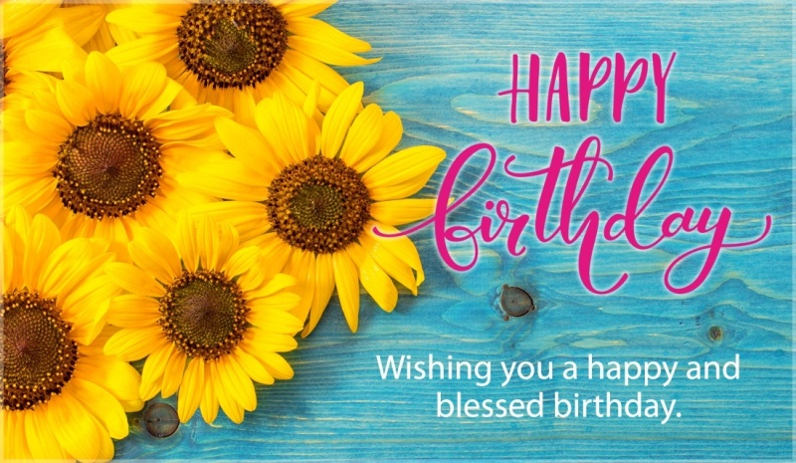
October 11 Louanne Vieau
October 15 Helga Chapp
October 16 Judy Moffit
October 17 Larry Respondek
Rodger Shutter
October 18 Celine Smith
October 19 Darren Barnes
Eugene Bowerman
Virginia Mulka
Richard Polus
October 23 Barbara Stovall
October 24 Pamela Dugan
Beverly Williams

