December | 2021  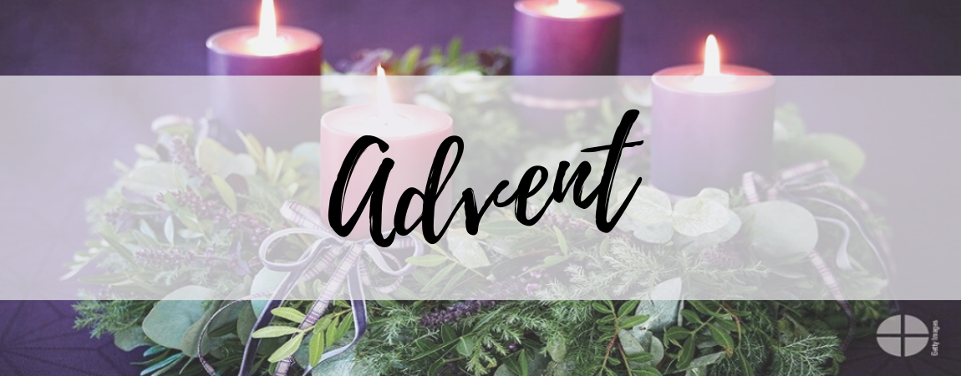

Our Lady of the Lake Catholic Church
Sunday | Monday | Tuesday | Wednesday | Thursday | Friday |  | Saturday
 |  |  | 1 | 2 | 3 |  | 4
 |  |  | 9:00 am Mass | 9:00 am Mass | First Friday Adoration  9:00 am Mass  Confessions  10:00 – 11:00 am |  | First Saturday  9:00 am Mass  Confessions 3:00pm  4:00 pm Mass
5 | 6 | 7 | 8 | 9 | 10 |  | 11
Second Sunday of Advent  Confessions  8:00am  9:00 am Mass  Youth Group  10-10:30 | No Mass | 9:00 am Mass  Immaculate Conception  Vigil Mass  4:00 pm | Immaculate Conception  9:00 am Mass | 9:00 am Mass | 9:00 am Mass  Confessions  10:00 – 11:00 am |  | Confessions 3:00pm  4:00 pm Mass
12 | 13 | 14 | 15 | 16 | 17 |  | 18
Third Sunday of Advent  Confessions  8:00am  9:00 am Mass  Faith formation 9:00am-11:00am | No Mass | 9:00 am Mass | 9:00 am Mass | 9:00 am Mass  Mass at the Brook  11:00  Advent Play  1 pm & 6 pm | 9:00 am Mass  Confessions  10:00 – 11:00 am |  | Confessions 3:00pm  4:00 pm Mass
19 | 20 | 21 | 22 | 23 | Office closed 24 |  | 25
Four Sunday of Advent  Confessions  8:00am  9:00 am Mass  Youth Group  5:00-8:00 pm | No Mass | 9:00 am Mass | 9:00 am Mass | 9:00 am Mass | Christmas Vigil  4:00 pm Mass  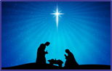 |  | The Nativity of the Lord  9:00 am Mass  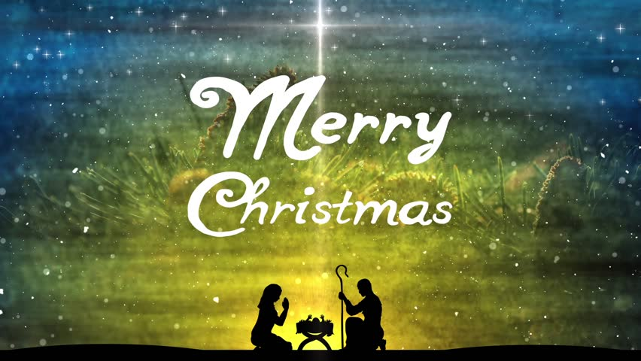
26 | Office closed 27 | Office closed 28 | Office closed 29 | Office closed 30 | Office closed 31 |  | January 1
The Holy Family of Jesus Mary & Joseph  Confessions  8:00am  9:00 am Mass | No Mass | 9:00 am Mass | 9:00 am Mass | 9:00 am Mass | The Solemnity of Mary  4:00 pm Mass |  |  | The Solemnity of Mary  9:00 am Mass  The Epiphany of the Lord  4:00 pm Mass
January 2
The Epiphany of the Lord  Confessions  8:00am  9:00 am Mass |  | Parish/School Office Hours: Monday – Friday 8:00 am – 4:00 pm.  If you need to reach Father Peter after hours, call the church office and dial Ext. 2  **The Parish/School office will be closed during the Holiday Break December 24th-  through January 2nd.

December Birthdays

December 2 Richard Baker
December 4 Jennie Detmer
Father Peter Eke
Betty Williams
Cary Yuncker
December 5 John Oles
December 6 Mary Konyha
December 9 Rhonda Gill
December 10 Myra Grixti
December 12 Linda Alberts
Giedre Stefankiewicz
December 14 Marie Hanses
December 15 Betty Delisle
December 16 Kay Green
Flora Miesel
Robert Pacella
December 17 Donna Bischoff
Kimberly Spurgeon
December 18 Rose Rose
December 19 Shelley Mader
December 21 Joyce Golden
Evelyn Maciha
December 22 Theresa Hutson-Collins
David Krug

December 23 Robert Sredzinski
December 24 Holly Bosel
December 25 Jamie Barnes
Kenneth Harrison
December 26 Michael Baumgartner
Daniel Collins
Janice Webber
December 27 Owen Barnes
Donna Langdon
Michael Mieske
December 28 Charlotte Crist
James Morse
Zander Rubino
December 30 Jamie Janco
Holly Oliver

