November  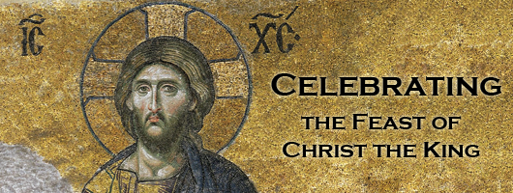 | 2021

Our Lady of the Lake Catholic Church
Sunday | Monday | Tuesday | Wednesday | Thursday | Friday | Saturday
 | 1 | 2 | 3 | 4 | 5 | 6
 | All Saints Day  Mass 9:00am  Mass 6:00pm | All Souls Day  Mass 9:00am  Candle Blessing 6:00 pm | 9:00 am Mass | 9:00 am Mass | First Friday Adoration  9:00 am Mass  Youth Group  Homeless Awareness 6:00 pm | First Saturday  9:00 am Mass  Confessions 3:00pm  4:00 pm Mass
7 | 8 | 9 | 10 | 11 | 12 | 13
9:00 am Mass  Daylight Savings Time Ends | No Mass | 9:00 am Mass  Altar Server Training 11:30 AM | 9:00 am Mass | 9:00 am Mass | 9:00 am Mass | Confessions 3:00pm  4:00 pm Mass
14 | 15 | 16 | 17 | 18 | 19 | 20
Confessions  8:00am  9:00 am Mass  Faith formation 9:00am-11:00am | No Mass  CCW Meeting  3:45 PM | 9:00 am Mass | 9:00 am Mass | 9:00 am Mass  Mass at the Brook  11:00 | 9:00 am Mass | Confessions 3:00pm  4:00 pm Mass
21 | 22 | 23 | 24 | 25 | 26 | 27
Christ the King Sunday  Confessions  8:00am  9:00 am Mass | No Mass | 9:00 am Mass | 9:00 am Mass  No School | 9:00 am Mass  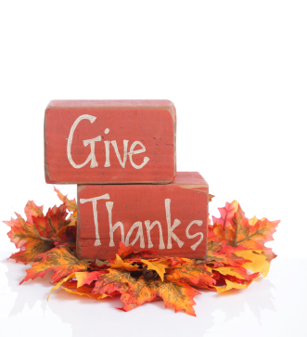  No School  Office Closed | 9:00 am Mass  No School  Office Closed | Confessions 3:00pm  4:00 pm Mass  St. Vincent de  Paul Collection
28 | 29 | 30
First Sunday of Advent  Confessions  8:00am  9:00 am Mass  St. Vincent de Paul Collection | No Mass | 9:00 am Mass | Parish/School Office Hours:  Monday – Friday 8:00 am – 4:00 pm.  If you need to reach Father Peter after hours, call the church office and dial Ext. 2  **The Parish/School office will be closed during the Thanksgiving Break November 25th  through November 26th.

November Birthdays

November 1 Kaylyn Allen
Ryleigh Foster
Sharon Mowery
November 3 Dolores Bliven
November 6 Patrick Seegraves
Michael Wilson
November 7 Robert Spicer
November 8 Julie Bovay
Carolyn Lamb
November 11 Daniel Dwyer
November 12 Mark Walters
November 13 Thomas Zadrozny
November 15 Michael Stuck
November 16 Tyler Haggart
Stephen Spurgeon
November 17 Marjorie Palm
William Tarrant
November 18 Sally Gross
November 19 Benjamin Walker
November 21 Heather King
November 23 Lindsey Hamel
November 24 Janet Steepe

November 25 Judith Brown
Robert Pacella
Amy Ruff
November 26 Brenda Gardner
November 27 Larry Aiello
Josephine Kirchler
November 28 Yvonne Neubecker

