April | 2022

Our Lady of the Lake Catholic Church
Sunday | Monday | Tuesday | Wednesday | Thursday | Friday | Saturday
 |  |  |  |  | 1 | 2
 |  |  |  |  | 9:00 am Mass | First Saturday  Adoration  9:00 am Mass  Confessions  3:00 pm  4:00 pm Mass  4:00 pm Mass
3 | 4 | 5 | 6 | 7 | 8 | 9
Confessions  8:00 am  9:00 am Mass  Faith Formation  9:00 am-11:00 am | No Mass | 9:00 am Mass  The Lenten Companion  5:00 pm | 9:00 am Mass  School Penance Service after School Mass  Parish Penance Service  5:00 pm | 9:00 am Mass  Mass at King’s Nursing Home  11:00 am  Holy Week Walkthrough Meeting  5:00 pm | 9:00 am Mass | Confessions  3:00 pm  4:00 pm Mass
10 | 11 | 12 | 13 | 14 | 15 | 16
Palm Sunday  Confessions  8:00 am  9:00 am Mass  Faith Formation  First Reconciliation  9:00 am-11:00 am | No Mass | 9:00 am  Chrism Mass  The Lenten Companion  5:00 pm | 9:00 am Mass | Holy Thursday  Office Closes at 3:00 pm  7:00 pm Mass of the Last Supper | Good Friday  Divine Mercy Novena Begins  No School  Office Closed  Stations of the Cross  1:00 pm  Good Friday Service 2:00 pm  Good Friday Service  2:00 pm | Holy Saturday  Blessing of Food  1:00 pm  Easter Vigil  9 :00 pm
17 | 18 | 19 | 20 | 21 | 22 | 23
Confessions  8:00 am  9:00 am Mass  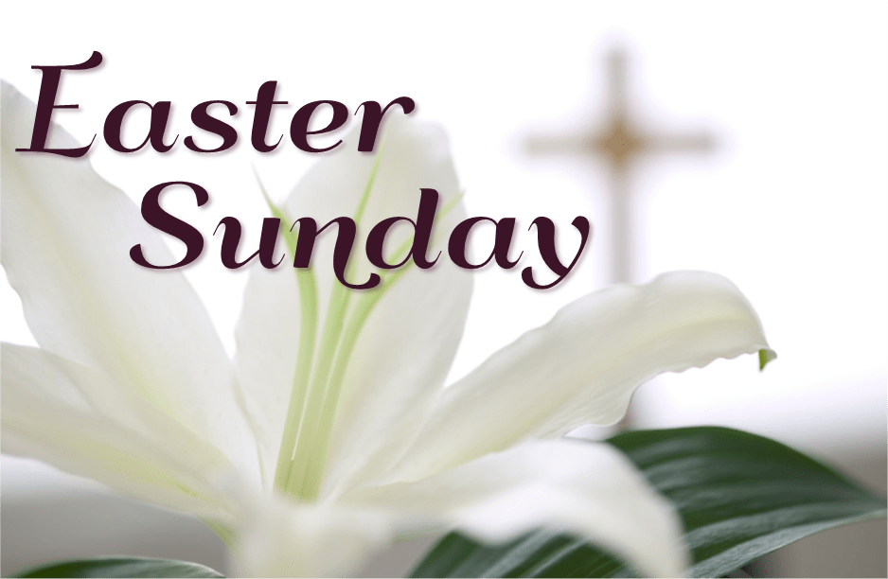 | No Mass  No School  Office Closed | No Mass | 9:00 am Mass | No Mass | No Mass | Confessions  3:00 pm  4:00 pm Mass  St. Vincent Collection
24 | 25 | 26 | 27 | 28 | 29 | 30
Confessions 8:00 am  9:00 am Mass  Youth Group  10 am-11:30 am  St. Vincent Collection  Divine Mercy Sunday  3:00 pm | No Mass  4:00 pm-6:00 pm Open House for New Families & Open Registration  Begins | No Mass | 9: 00 am Mass | No Mass | No Mass | Confessions  3:00 pm  4:00 pm Mass
Parish/School Office Hours: Monday – Friday 8:00 am – 4:00 pm.
Upcoming Events:
May Crowning Mass: May 1st at 9 am
Mission Meeting: May 14th at 9 am
Memorial Day Mass: May 30th at 9 am

If you need to reach Father Peter after hours, call the church office and chose option 2.
Confession Times: Saturdays 3:00 PM
Sundays 8:00 AM

April Birthdays

April 1 Morgan Stadler
April 17 Jeremiah Dull
Mary Munn
Jennifer Wall
April 18 Amy Hagerl
April 19 Anne Hodgson
Joel Hodgson
April 21 Chester Gacioch
Howard Norris
April 22 David Unger
April 26 Joseph Hood
April 27 Nelly Anker
Kathleen Everett
Robert Westen
April 28 Emily King
April 29 Jessica Speer
April 30 Christopher Scheele
Sally Szewczyk

April 2 James Kirchler
Sally Zamora
April 3 John Early
April 4 Robert VanSickle
April 6 Mary Bloomfield
Brandon King
April 7 Michael Baumgartner
Sharon Gentner
Dexter Wilson
April 10 Thomas Powers
April 11 Rick Radulski
April 14 Robert Henderson
Lorraine Roemelen
April 15 Pamela Meier
April 16 Russel Hoover
Raymond Whipple

