May | 2022

Our Lady of the Lake Catholic Church
Sunday | Monday | Tuesday | Wednesday | Thursday | Friday | Saturday
1 | 2 | 3 | 4 | 5 | 6 | 7
Confessions  8:00 am  9:00 am Mass  May Crowning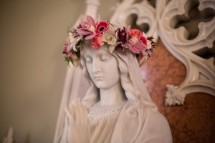  Youth Ministry  10:00 am-11:30 am  Faith Formation  9:00 am-11:00 am | No Mass | No Mass | 9:00 am Mass  School May Crowning  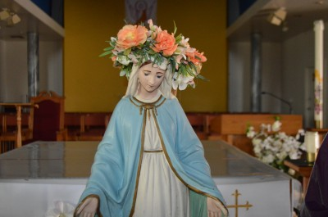 | No Mass | No Mass | No First Saturday Mass  Confessions  3:00 pm  4:00 pm Mass
8 | 9 | 10 | 11 | 12 | 13 | 14
Mother’s Day  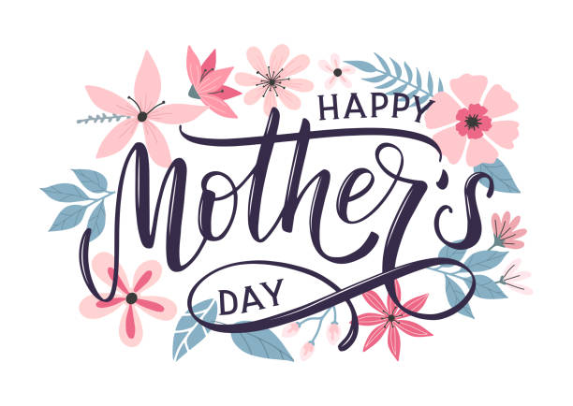  Confessions  8:00 am  9:00 am Mass | No Mass | No Mass | 9:00 am Mass | No Mass | No Mass | Parish Mission Meeting  9:00 am  Confessions  3:00 pm  4:00 pm Mass
15 | 16 | 17 | 18 | 19 | 20 | 21
Confessions  8:00 am  9:00 am Mass  Youth Ministry  10:00 am-11:30 am  Faith Formation  9:00 am-11:00 am | No Mass | 9:00 am Mass | 9:00 am Mass | 9:00 am Mass  Mass at the Brook  11:00 am | 9:00 am Mass | Confessions  3:00 pm  4:00 pm Mass
22 | 23 | 24 | 25 | 26 | 27 | 28
Confessions  8:00 am  9:00 am Mass  Faith Formation  9:00 am-11:00 am | No Mass | 9:00 am Mass | 9:00 am Mass | 9: 00 am Mass | 9:00 am Mass | Confessions  3:00 pm  4:00 pm Mass  St. Vincent  Collection
29 | 30 | 31
Confessions  8:00 am  9:00 am Mass  St. Vincent  Collection | 9:00 am Mass  Memorial Day  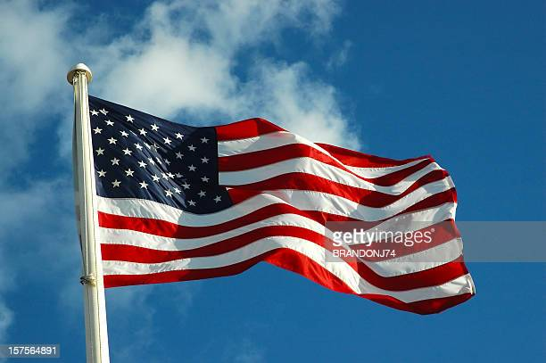  Office Closed | 9:00 am Mass
Parish/School Office Hours: Monday – Friday 8:00 am – 4:00 pm.
Upcoming Events in June:
June 3rd- 6 pm Faith Formation Practice
June 5th- 9 am Celebration of the Sacraments

If you need to reach Father Peter after hours, call the church office and select Ext. 2
Confession Times: Saturdays 3:00 PM
Sundays 8:00 AM

May Birthdays

May 1 Joseph Shereda
May 19 Payton Dull
May 20 Gregory Brown
Adam Speer
Mr. Leo Wekwert
May 21 Abbey Bosel
Dennis Brown
May 22 Chad Watson
May 24 Laura Shea
May 27 Mariah Benson
May 29 Bernard Malkowkski
Carol Toswell
May 30 Savannah Danes
Michael Major
Patricia Polus
May 31 Colin Janco

May 2 Patricia Partyka
May 3 Mrs. Larisa Walters
May 6 Dorothy Bowerman
Joyce Klee
David Shanahan
May 7 Jessica Tyo
May 8 Janice Detmer
Irene Hoetger
Evelyn Lawson
May 9 Jean Taube
May 11 Rebecca Buccilli
May 13 Corrie Stadler
May 14 John McGinn
May 15 Donald Mulka
May 17 Carol Post
Karen Richards
Brian Trupp

