13Th Annual Golf Outing

Golf Outing and Dinner Fundraiser
Pineview Highlands Golf Course
Friday, May 29th, 2026
Shotgun Start at 9 AM
Support Our Lady of the Lake Regional Catholic School
One Swing at a Time
Join us for a fun-filled day on the course, followed by a delicious catered dinner and entertainment.

18 Hole Scramble with Cart, Hot Dog or Pulled Pork at the Turn, Closest to the Pin, Longest Drive, Straightest Drive, Skins Contest, 50/50 Drawing, Hole in One, Prizes in Three Flights, Catered Dinner, Entertainment, and Silent Auction.
Whether you're a golf pro or just in it for the good times, come out and make a difference.
All proceeds benefit Our Lady of the Lake Regional Catholic School.

$80.00 for Individual Golfer (if registered before April 29th)
$320.00 for a foursome (if registered before April 29th)
$500.00 Hole-in-One Team Sponsor Foursome, Hole signage (fill out Sponsorship form), and Team Name on Grandstand recognition. Place the team’s name on the registration form, along with the golfers’ names. Due No Later Than May 8th
$90.00 for Individual Golfer (if registered after April 29th)
$360.00 for a foursome (if registered after April 29th)
Golfer Registration form due: May 19th
2026 Team/Individual Registration Form

TEAM Name if Hole-in-One Team Sponsor: _____________________________________________________________________________

Golfer 1: Name_______________________Address__________________________________PH#____________
Golfer 2: Name_______________________Address__________________________________PH#____________
Golfer 3: Name_______________________Address__________________________________PH#____________
Golfer 4: Name_______________________Address__________________________________PH#____________
Dinner Only Tickets $40.00 each Number of Tickets______________
4:00 pm Drinks (Cash Bar)
4:30 pm Dinner and Entertainment by Logan Moore (sponsored by Loose Plastics Inc.)
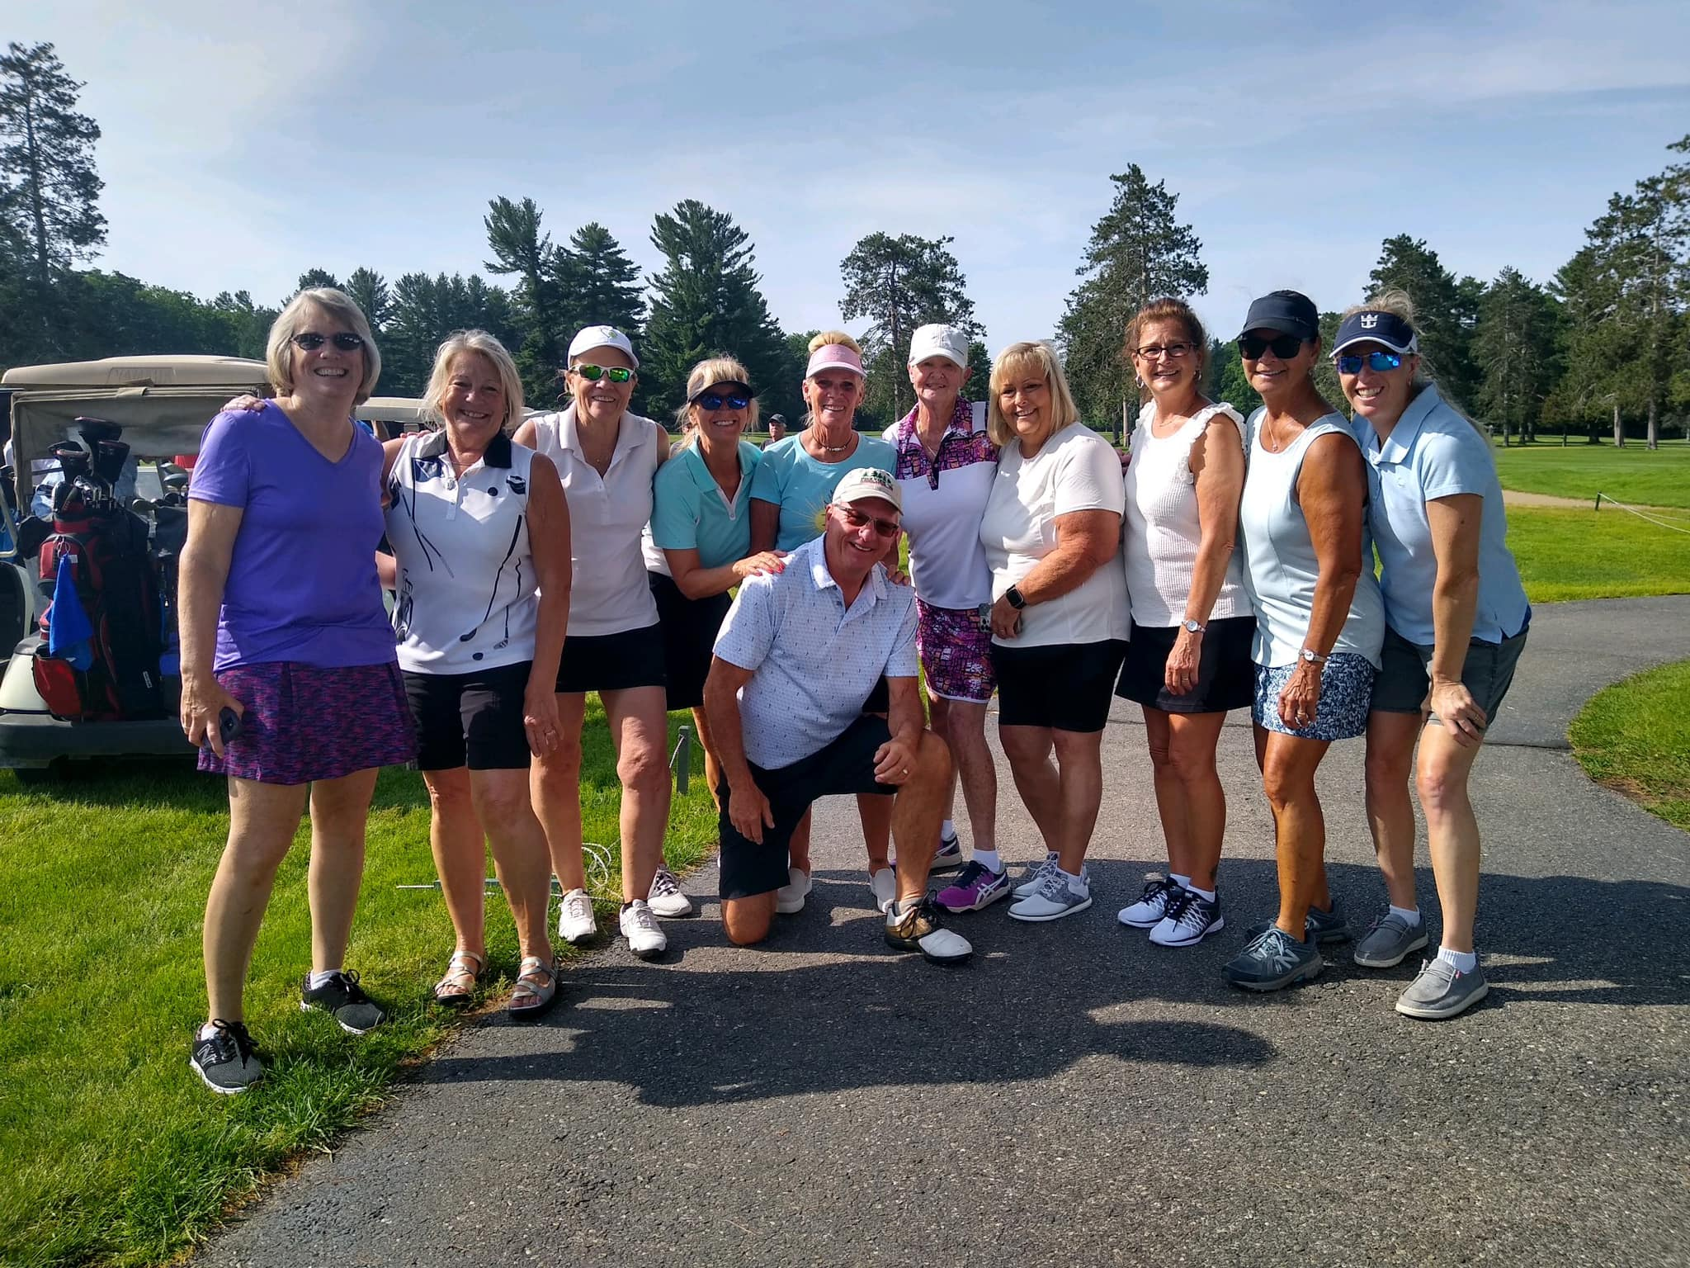
5:30 pm Raffle and Prizes

Please Make Checks Payable To: OLLRCS
Mail To: PO Box 800, Prudenville, MI 48651
OLLRCS Office: 989-366-5592

Amount Enclosed: $______________
13Th Annual Golf Outing
Golf Outing and Dinner Fundraiser
Friday, May 29, 2026
Sponsorship
Sponsorship Forms Due May 8th

Business Name ________________________________________________Phone______________________
Business Address___________________________________________________________________________
Contact Name__________________________________ Contact email______________________________
Please select sponsorship
___ $100.00 (24x24 signage) Hole Name on Sign______________________________________________
___ $0.00 Hole -in-One Team Sponsor (24x24 signage) Hole Name on Sign__________________________________
___Any Door Prize Donation (gift certificate or gift card) will appear on a “Thank You” board located at the clubhouse and school Facebook page.
Door Prize Donation of $_______________________

Golf Package Sponsorship:
___Hole in one sponsor
___Flight Sponsor
18 Holes of Golf with Cart for four people with advertisement swag
___Closest to the Pin Sponsor
18 Holes of Golf with Cart for one with advertisement swag
__Longest Drive Sponsor
9 Holes of Golf with Cart for one with advertisement swag
__Straightest Drive Sponsor
9 Holes of Golf with Cart for one with advertisement swag
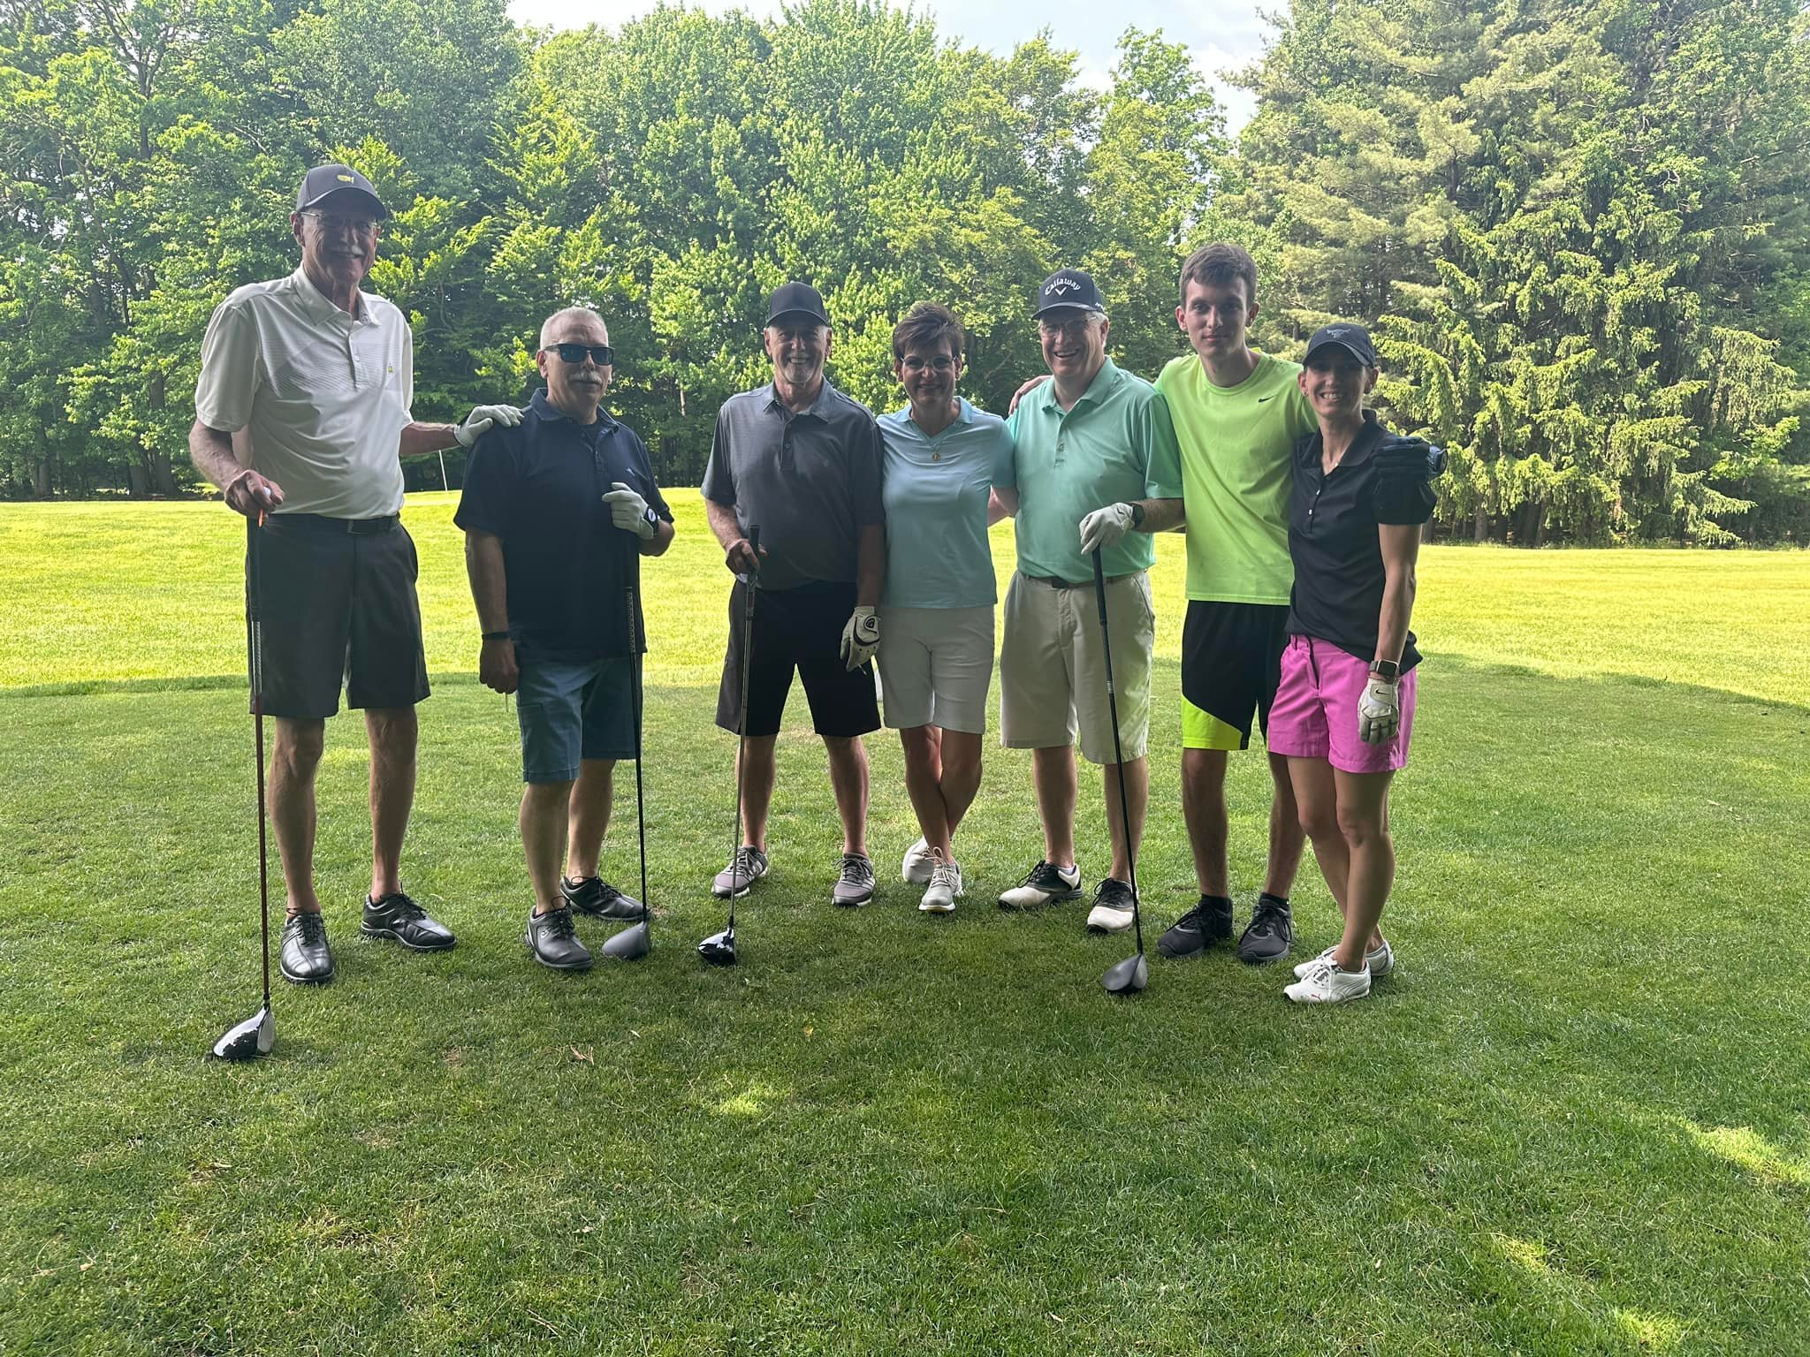

Please Make Checks Payable To: OLLRCS
Mail To: PO Box 800, Prudenville, MI 48651
OLLRCS Office: 989-366-5592
Amount Enclosed: $_______________

