July | 2022

Our Lady of the Lake Catholic Church
Sunday | Monday | Tuesday | Wednesday | Thursday | Friday | Saturday
 |  |  |  |  | 1 | 2
 |  |  |  |  | 9:00 am Mass | First Saturday  9:00 am Mass  Confessions  3:00 pm  4:00 pm Mass
3 | 4 | 5 | 6 | 7 | 8 | 9
Confessions  8:00 am  9:00 am Mass | 9:00 Mass  Office Closed | 9:00 am Mass | 9:00 am Mass | 9:00 am Mass | 9:00 am Mass | Confessions  3:00 pm  4:00 pm Mass
10 | 11 | 12 | 13 | 14 | 15 | 16
Confessions  8:00 am  9:00 am Mass | No Mass | 9:00 am Mass | 9:00 am Mass | 9:00 am Mass | 9: 00 am Mass | Confessions  3:00 pm  4:00 pm Mass
17 | 18 | 19 | 20 | 21 | 22 | 23
Confessions  8:00 am  9:00 am Mass | No Mass  CCW Meeting  4:00 pm | 9:00 am Mass | 9:00 am Mass | 9:00 am Mass  Mass at the Brook  11:00 am | 9:00 am Mass | Confessions  3:00 pm  4:00 pm Mass
24 | 25 | 26 | 27 | 28 | 29 | 30
Confessions  8:00 am  9:00 am Mass  Father Peter’s Silver Jubilee  4:00 pm | No Mass | 9:00 am Mass | 9:00 am Mass | 9:00 am Mass  Mass at King’s Nursing Home  11:00 am | 9:00 am Mass | Confessions  3:00 pm  4:00 pm Mass  St. Vincent Collection
31
Confessions
3:00 pm

4:00 pm Mass

St. Vincent Collection
Parish/School Office Hours: Monday – Friday 8:00 am – 1:00 pm.
Upcoming Events in August:

August 14th: Parish Picnic at 4 p.m.

August 17th: School Open House @ 5 p.m.
If you need to reach Father Peter after hours, call the church office
and select Ext. 2
Confession Times: Saturdays 3:00 PM
Sundays 8:00 AM

July Birthdays 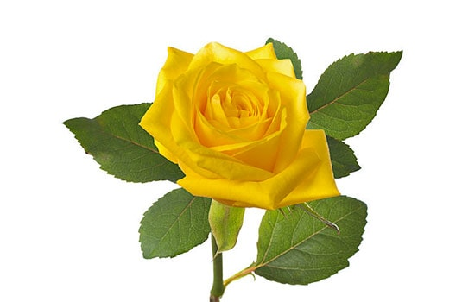
July 18 Judy Davey
July 19 Joseph Coleman
July 22 Kenneth Todd
Bruce Walters, M.D.
July 24 William Oliver
Joann Zadrozny
July 25 Patricia Henderson
July 27 Sidney Horski
William Nippes
Kathy Parker
July 28 Ronald Klee
Dawn LaCasse
Carolyn Pietchak
Stacey Wierzbicki
Zachary Yuncker
July 29 Ronald Meiring
July 30 Stephanie Harris
Joyce Stuck
July 31 Mrs. Vicky Faino

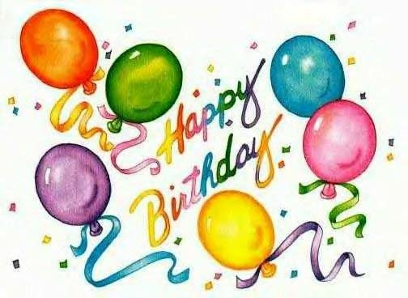
July 2 Madelyn Yuncker
July 4 Francis Kronner
Michael Silva
July 5 April Johnson
Doris Johnson
July 6 Christina Danes
Alexandra Hood
July 8 Jennifer Beery
Joseph Meyers
Mary Wakeen
July 9 Mary Walker
July 10 Gary Gill, Jr.
July 11 Martha Norris
July 12 Michael Detmer
Virginia DeVisscher
Michael Dushan
Carol Wyszynski
July 13 Barbara Falls
July 14 Vernon Anderson
July 15 Kayla Champagne
Madalyn Mieske
July 16 Mya Hagerl
Farrah Janco
Margaret Shereda

