October | 2022

Our Lady of the Lake Catholic Church
Sunday | Monday | Tuesday | Wednesday | Thursday | Friday | Saturday
 |  |  |  |  |  | 1
First Saturday
9:00 am Mass
Confessions 3:00 pm
4:00 pm Mass
2 | 3 | 4 | 5 | 6 | 7 | 8
Confessions  8:00 am  9:00 am Mass  Faith Formation  10-11:30 am  Blessing of Pets  11:00 am | No Mass | 9:00 am Mass | 9:00 am Mass | 9:00 am Mass | First Friday Adoration  9:00 am Mass | Confessions 3:00 pm  4:00 pm Mass
9 | 10 | 11 | 12 | 13 | 14 | 15
Confessions  8:00 am  9:00 am Mass | No Mass | 9:00 am Mass | 9:00 am Mass with  Bishop Walsh  Blessing of the Grotto | 9:00 am Mass  Mass at King’s Nursing Home  11:00 am | 9:00 am Mass | Confessions 3:00 pm  4:00 pm Mass
16 | 17 | 18 | 19 | 20 | 21 | 22
Confessions  8:00 am  9:00 am Mass  Faith Formation  10-11:30 am | No Mass  CCW Meeting  4:00 pm | 9:00 am Mass | 9:00 am Mass | 9:00 am Mass  Mass at the Brook  11:00 am | 9:00 am Mass | Confessions 3:00 pm  4:00 pm Mass
23 | 24 | 25 | 26 | 27 | 28 | 29
Confessions  8:00 am  9:00 am Mass | No Mass | 9:00 am Mass | 9:00 am Mass | 9:00 am Mass | 9:00 am Mass | Confessions 3:00 pm  4:00 pm Mass  St. Vincent Collection
30 | 31
Confessions  8:00 am  9:00 am Mass  St. Vincent Collection | No Mass
Parish/School Office Hours: Monday – Friday 8:00 am – 4:00 pm. If you need to reach Father Peter after hours, call the church office
Upcoming Events in November:
November 1st: All Saint’s Day: School Mass 9:00 am
& Mass 4:00 pm
November 2nd: Blessing of the Candles: School Mass
9:00 am & Mass 4:00 pm
November 24th: Thanksgiving Day Mass 9:00 am
and select Ext. 2.
Confession Times: Saturdays: 3:00 PM
Sundays: 8:00 AM

October Birthdays

October 23 Barbara Stovall
October 24 Pamela Dugan
Beverly Williams
October 25 Gary Chapp
October 26 Helen Schrank
October 28 Charlotte Sredzinski
October 29 Madison Speer
October 30 Marion Post
October 31 Haleigh Foster
Mark Giasson
Patrick Torres

October 2 George Everett
Allison Hood
October 5 Michael Mackey
Carol Spindler
October 7 Laurie Chudzinski
Timothy Cowan
Tyler Silva
October 8 Edmund Lipon
October 10 Michael Beech
Barbara Parol
Mary Speer
October 11 Louanne Vieau

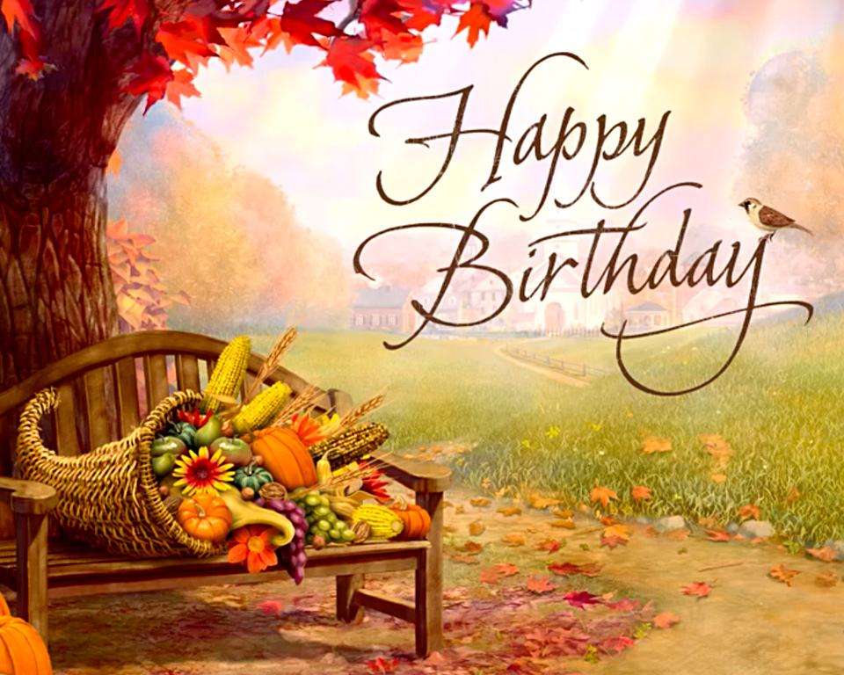
October 12 George Mika
October 15 Helga Chapp
October 16 Judy Moffit
October 17 Larry Respondek
Rodger Shutter
October 18 Celine Smith
October 19 Darren Barnes
Eugene Bowerman
Virginia Mulka
Richard Polus

