September | 2022

Our Lady of the Lake Catholic Church
Sunday | Monday | Tuesday | Wednesday | Thursday | Friday | Saturday
 |  |  |  | 1 | 2 | 3
 |  |  |  | 9:00 am Mass | First Friday  Adoration  9:00 am Mass | First Saturday  9:00 am Mass  Confessions  3:00 pm  4:00 pm Mass
4 | 5 | 6 | 7 | 8 | 9 | 10
Confessions  8:00 am  9:00 am Mass | 9:00 Mass  Labor Day  Office Closed | 9:00 am Mass | 9:00 am Mass | 9:00 am Mass | 9:00 am Mass | Confessions  3:00 pm  4:00 pm Mass
11 | 12 | 13 | 14 | 15 | 16 | 17
Confessions  8:00 am  9:00 am Mass  Parish Mission  6:30 pm | 9:00 am Mass  Parish Mission  6:30 pm | 9:00 am Mass  Parish Mission  Confessions  6:30 pm | 9:00 am Mass  Parish Mission  6:30 pm | Mass at King’s Nursing Home  11:00 am  6:30 pm Mass  Parish Mission  6:30 pm | 9:00 am Mass | Confessions  3:00 pm  4:00 pm Mass
18 | 19 | 20 | 21 | 22 | 23 | 24
Confessions  8:00 am  9:00 am Mass | No Mass  CCW Meeting  4:00 pm  Priest’s Convocation in Cadillac | No Mass  Priest’s Convocation in Cadillac | No Mass  Priest’s Convocation in Cadillac | No Mass  Priest’s Convocation in Cadillac | 9:00 am Mass | Confessions  3:00 pm  4:00 pm Mass  St. Vincent Collection
25 | 26 | 27 | 28 | 29 | 30
Confessions  8:00 am  9:00 am Mass  St. Vincent Collection | No Mass | 9:00 am Mass | 9:00 am Mass | 9:00 am Mass  Mass at the Brook  11:00 am | 9:00 am Mass
Parish/School Office Hours: Monday – Friday 8:00 am – 4:00 pm.
Upcoming Events in October:
October 2nd: 11:00 am Blessing of the Pets
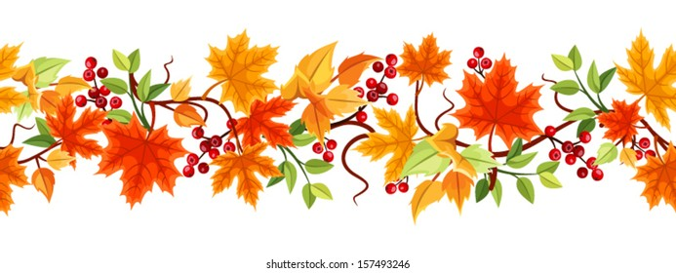
If you need to reach Father Peter after hours, call the church office
and select Ext. 2
Confession Times: Saturdays 3:00 PM
Sundays 8:00 AM

September Birthdays

September 22 Trevor Lawrence
Duane Vieau
September 23 Diana Breier
September 24 Mr. Terry Bassett
Louis Buccilli
David Johnson
Darlene Kinsley
September 27 Tracey Haggart
Byron Janisse
Candace Wejroch
September 28 Daniel Hopkins
September 29 Phyllis Anderson
September 30 Tina Kelley

September 1 Jean Smith
Gregory Wick
September 2 Larry Meier
September 3 Danny Silva
JoAnn Warner
September 4 Brenner Wilson
September 5 Lauren Haggart
September 6 Kate Elias
September 7 Joseph Chudzinski
Gerald Mader
September 9 Angie Whipple
September 11 Steve Thompson
September 13 Jon Dean
September 14 Deborah Morse
September 15 Mrs. Janet Bassett
Joseph Michalski
Richard Tyo
September 16 Elouise Pohl
September 17 Kathleen Gacioch
William Scheele
September 20 Jose Silva
September 21 Madyson Bovay
Lenore Pastula

