November | 2022

Our Lady of the Lake Catholic Church
Sunday | Monday | Tuesday | Wednesday | Thursday | Friday | Saturday
 |  | 1 | 2 | 3 | 4 | 5
 |  | All Saints’ Day  9:00 am School Mass  6:00 pm Mass | All Souls’ Day  9:00 am Mass  Candle Blessing  6:00 pm Mass | 9:00 am Mass | First Friday Adoration  9:00 am Mass | First Saturday  9:00 am Mass  Confessions 3:00 pm  4:00 pm Mass
6 | 7 | 8 | 9 | 10 | 11 | 12
Confessions  8:00 am  9:00 am Mass  Faith Formation  10-11:30 am | No Mass | 9:00 am Mass | 9:00 am Mass | 9:00 am Mass  Mass at King’s Nursing Home  11:00 am | 9:00 am Mass | Confessions 3:00 pm  4:00 pm Mass
13 | 14 | 15 | 16 | 17 | 18 | 19
Confessions  8:00 am  9:00 am Mass | No Mass | 9:00 am Mass | 9:00 am Mass | 9:00 am Mass  Mass at the Brook  11:00 am | 9:00 am Mass | Confessions 3:00 pm  4:00 pm Mass
20 | 21 | 22 | 23 | 24 | 25 | 26
Confessions  8:00 am  9:00 am Mass  Faith Formation  10-11:30 am | No Mass  CCW Meeting  4:00 pm | 9:00 am Mass | 9:00 am Mass | Thanksgiving Day  9:00 am Mass  Office Closed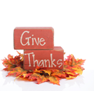 | 9:00 am Mass  Office Closed | Confessions 3:00 pm  4:00 pm Mass  St. Vincent Collection
27 | 28 | 29 | 30
Confessions  8:00 am  9:00 am Mass  St. Vincent Collection | No Mass | 9:00 am Mass | 9:00 am Mass
Parish/School Office Hours: Monday – Friday 8:00 am – 4:00 pm. If you need to reach Father Peter after hours, call the church office
Upcoming Events in December:
December 8th: The Immaculate Conception of the Blessed Virgin Mary, 9:00 am Mass
December 11th: Christmas Party 4:00 pm
December 15th: Penance Service 5:00 pm
December 24th: Christmas Eve Mass 4:00 pm
December 25th: Christmas Day Mass 9:00 am
and select Ext. 2.
Confession Times: Saturdays: 3:00 PM
Sundays: 8:00 AM

November Birthdays

November 21 Heather King

November 22 David Willemot

November 23 Lindsey Hamel

November 24 Janet Steepe

November 25 Judith Brown

Robert Pacella

Amy Ruff

November 26 Brenda Gardner

November 27 Larry Aiello

Josephine Kirchler

November 28 Yvonne Neubecker

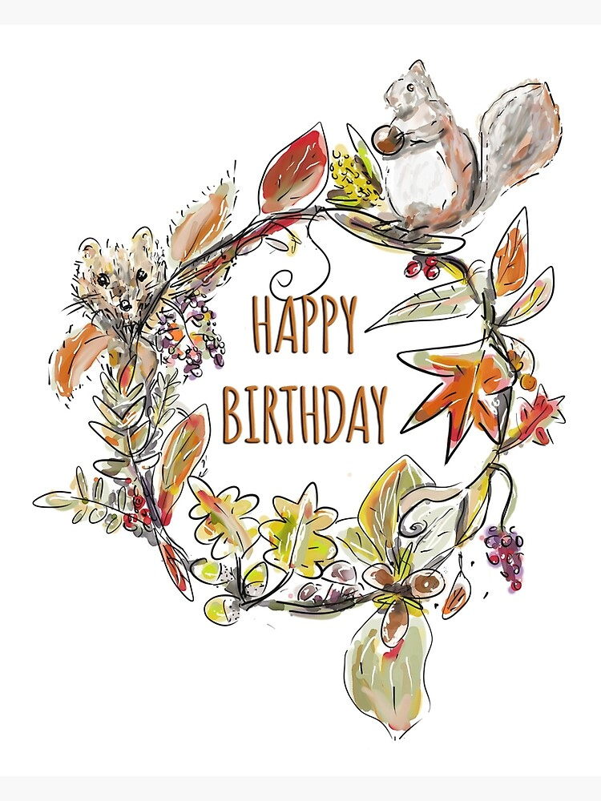

November 1 Kaylyn Allen

Ryleigh Foster

Sharon Mowery

November 3 Dolores Bliven

November 6 Patrick Seegraves

November 7 Robert Spicer

November 8 Julie Bovay

Carolyn Lamb

November 11 Daniel Dwyer

November 12 Mark Walters

November 13 Thomas Zadrozny

November 15 Michael Stuck

November 16 Tyler Haggart

Stephen Spurgeon

November 17 Carol Breyer

Marjorie Palm

William Tarrant

November 18 Sally Gross

November 19 Benjamin Walker

