May | 2023

Our Lady of the Lake Catholic Church
Sunday | Monday | Tuesday | Wednesday | Thursday | Friday | Saturday
 | 1 | 2 | 3 | 4 | 5 | 6
 | No Mass | 9:00 am Mass  Book Study  6:00 pm | 9:00 am Mass  School May Crowning  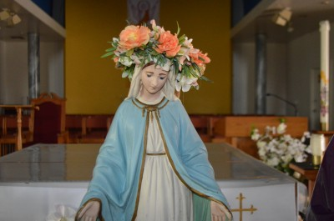  Unlocking the Mystery of the Bible Class  5:00 pm | 9:00 am Mass | First Friday Adoration  9:00 am Mass | First Saturday  9:00 am Mass  Confessions  3:00 pm  4:00 pm Mass
7 | 8 | 9 | 10 | 11 | 12 | 13
Confessions  8:00 am  9:00 am Mass  May Crowning  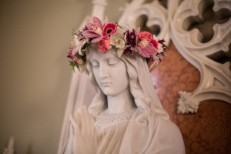  Faith Formation  10-11:30 am | No Mass | 9:00 am Mass  Welcome Giving Team Meetings  6:30 pm | 9:00 am Mass  Unlocking the Mystery of the Bible Class  5:00 pm | 9:00 am Mass  11:00 am  Mass at King’s Nursing Home | 9:00 am Mass | Confessions  3:00 pm  4:00 pm Mass
14 | 15 | 16 | 17 | 18 | 19 | 20
Mother’s Day  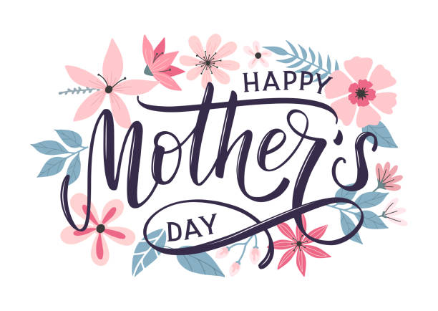  Confessions  8:00 am  9:00 am Mass | No Mass  CCW Meeting  4:00 pm | No Mass  Book Study  6:00 pm | No Mass  Unlocking the Mystery of the Bible Class  5:00 pm | 9:00 am  School Mass  11:00 am  Mass at Brook | 9:00 am Mass | Confessions  3:00 pm  4:00 pm Mass
21 | 22 | 23 | 24 | 25 | 26 | 27
Confessions  8:00 am  9:00 am Mass  Faith Formation  10-11:30 am | No Mass | 9:00 am Mass  Welcome Giving Team Meetings  6:30 pm | 9:00 am Mass  Kindergarten Graduation  1:00 pm  Unlocking the Mystery of the Bible Class  5:00 pm | 9:00 am Mass | 9:00 am Mass | Confessions  3:00 pm  4:00 pm Mass  St. Vincent Collection
28 | 29 | 30 | 31
Confessions  8:00 am  9:00 am Mass  St. Vincent Collection | 9:00 am Mass  Memorial Day  Office Closed | 9:00 am Mass  Book Study  6:00 pm | 9:00 am Mass  Unlocking the Mystery of the Bible Class  5:00 pm
Parish/School Office Hours:
Vacation Bible School
June 19th-23rd
Upcoming Events in June:
June 2nd- OLLRCS Golf Outing, 10:00 am at Pineview Highlands Golf Course
June 18th- Father’s Day, 9:00 am Mass
Monday – Friday 8:00 am – 4:00 pm
If you need to reach Father Peter after hours,
call the church office and select Ext.2.
Confession Times: Saturdays: 3:00 PM, Sundays: 8:00 AM

May Birthdays

May 1 Joseph Shereda
May 19 Payton Dull
May 20 Gregory Brown
Adam Speer
Mr. Leo Wekwert
May 21 Abbey Bosel
Dennis Brown
May 22 Chad Watson
May 24 Laura Shea
May 27 Mariah Benson
May 29 Bernard Malkowkski
Carol Toswell
May 30 Savannah Danes
Michael Major
Patricia Polus
May 31 Colin Janco

May 3 Mrs. Larisa Walters
May 6 Dorothy Bowerman
Joyce Klee
David Shanahan
May 7 Jessica Tyo
May 8 Janice Detmer
Irene Hoetger
Evelyn Lawson
May 9 Jean Taube
May 11 Rebecca Buccilli
May 13 Corrie Stadler
May 14 John McGinn
May 17 Carol Post
Karen Richards
Brian Trupp

