October | 2023

Our Lady of the Lake Catholic Church
Sunday | Monday | Tuesday | Wednesday | Thursday | Friday | Saturday
1 | 2 | 3 | 4 | 5 | 6 | 7
Confessions  8:00 am  9:00 am Mass  Faith Formation  9:00 am-11:00 am  Blessing of Pets  11:00 am | No Mass | 9:00 am Mass | 9:00 am Mass  5 hours of Adoration  10 am - 3 pm  Confession  11 am – 12 pm | 9:00 am Mass | First Friday Adoration  9:00 am Mass | First Saturday  9:00 am Mass  Confessions  3:00 pm  4:00 pm Mass  Stargazer Gala 5:00 pm
8 | 9 | 10 | 11 | 12 | 13 | 14
Confessions  8:00 am  9:00 am Mass | No Mass | No Mass | No Mass  5 hours of Adoration  10 am - 3 pm | No Mass | 9:00 am Mass | Confessions 3:00 pm  4:00 pm Mass  Women’s  Welcome Retreat
15 | 16 | 17 | 18 | 19 | 20 | 21
Confessions  8:00 am  9:00 am Mass  Faith Formation  9:00 am-11:00 am  Women’s  Welcome Retreat | No Mass  CCW Meeting  4:00 pm | 9:00 am Mass | 9:00 am Mass  5 hours of Adoration  10 am - 3 pm  Confession  11 am – 12 pm | 9:00 am Mass  Mass at King’s Nursing Home  11:00 am | 9:00 am Mass | Confessions 3:00 pm  4:00 pm Mass
22 | 23 | 24 | 25 | 26 | 27 | 28
Confessions  8:00 am  9:00 am Mass | No Mass | 9:00 am Mass | 9:00 am Mass  5 hours of Adoration  10 am - 3 pm  Confession  11 am – 12 pm | 9:00 am Mass  Mass at the Brook  11:00 am | 9:00 am Mass | Confessions 3:00 pm  4:00 pm Mass  St. Vincent Collection
29 | 30 | 31 |  |  |  | 29
Confessions  8:00 am  9:00 am Mass  St. Vincent Collection  Faith Formation  9:00 am-11:00 am | No Mass | 9:00 am Mass  All Saints’ Day  Vigil Mass  4:00 pm
Parish/School Office Hours: Monday – Friday 8:00 am – 4:00 pm.
Upcoming Events in November:
November 1st: All Saints’ Day: 9:00 am Mass
November 2nd: All Souls’ Day:
9:00 am Mass/Candle Blessing & 4:00 pm Mass November 23rd: Thanksgiving Day Mass 9:00 am
If you need to reach Father Peter after hours,
call the church office and select Ext. 2.
Confession Times: Saturdays: 3:00 PM
Sundays: 8:00 AM

October Birthdays

October 18 Celine Smith
October 19 Darren Barnes
Eugene Bowerman
Virginia Mulka
Richard Polus
October 23 Barbara Stovall
October 24 Pamela Dugan
October 25 Gary Chapp
October 28 Charlotte Sredzinski
October 29 Madison Speer
October 30 Marion Post
October 31 Haleigh Foster
Mark Giasson
Patrick Torres

October 2 George Everett
Allison Hood
October 5 Michael Mackey
Carol Spindler
Daniel Zielinski
October 7 Laurie Chudzinski
Timothy Cowan
Tyler Silva
October 8 Edmund Lipon
October 10 Michael Beech
Barbara Parol
Mary Speer
October 11 Louanne Vieau

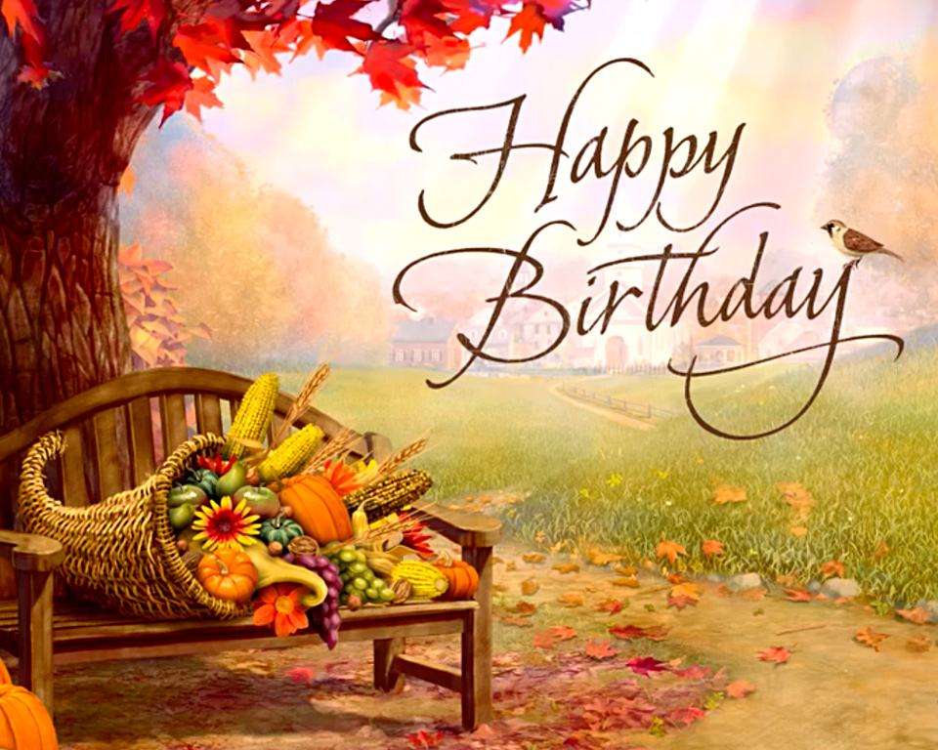

October 12 George Mika
October 15 Helga Chapp
October 16 Judy Moffit
October 17 Larry Respondek
Rodger Shutter

