May | 2024

Our Lady of the Lake, St James, St Hubert
Sunday | Monday | Tuesday | Wednesday | Thursday | Friday | Saturday
 |  |  | 1 | 2 | 3 | 4
 |  |  | 9:00 am Mass-OLL  School May Crowning  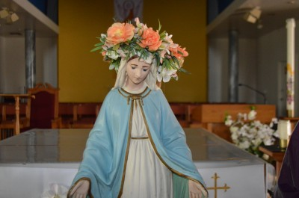  9:00 am Mass-St. J  Lectio: The Gospel of Mark  5:30 pm OLL | 9:00 am Mass-OLL  9:00 am Mass-St. J | First Friday Adoration  9:00 am Mass-OLL  Confessions  10:00 am-OLL  Anointing of the Sick-OLL | First Saturday  9:00 am Mass-OLL  Confessions  3:00 pm-OLL  4:00 pm Mass-OLL
5 | 6 | 7 | 8 | 9 | 10 | 11
Confessions  8:00 am-OLL  8:30 am-St. J  10:30 am-St. H  9:00 am Mass-OLL  Faith Formation OLL  9:00 am-11:00 am  9:00 am Mass-St. J  11:00 am Mass-St. H  May Crowning  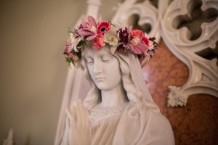 | 9:00 am Mass-St. J | 9:00 am Mass-OLL  9:00 am Mass-St. J  Book Study  5:30 pm OLL | 9:00 am Mass-OLL  9:00 am Mass-St. J  5 Hours of Adoration  10 am-3pm OLL  Confession  11am-12pm OLL  Ladies’ Card Club  1:00 pm-4:00 pm St. J  Lectio: The Gospel of Mark  5:30 pm OLL | 9:00 am Mass-OLL  9:00 am Mass-St. J  Mass at King’s Nursing Home  11:00 am  CWC  11:30 am St. H | 9:00 am Mass-OLL  Women’s Luncheon-St. J  Cazadores in West Branch 11:30 am | Confessions  3:00 pm-OLL  4:00 pm Mass-OLL  Euchre Party  1:30 Pm-St. J  Walk/Run for Life  9:00 am Ogemaw Heights High School
12 | 13 | 14 | 15 | 16 | 17 | 18
Mother’s Day  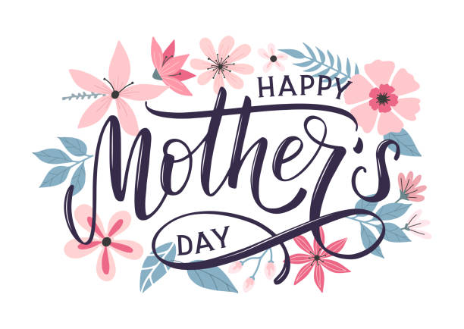  Confessions  8:00 am-OLL  8:30 am-St. J  10:30 am-St. H  9:00 am Mass-OLL  9:00 am Mass-St. J  11:00 am Mass-St. H | 9:00 am Mass-St. H  Men’s Club  6:30 pm St. H | 9:00 am Mass-OLL  9:00 am Mass-St. H  Welcome Team Meeting  5:30-6:45 pm  OLL | 9:00 am Mass-OLL  9:00 am Mass-St. H  5 hours of Adoration  10 am-3 pm OLL  Confession  11 am-12 pm OLL  Lectio: The Gospel of Mark  5:30 pm OLL | 9:00 am Mass-OLL  9:00 am Mass-St. H  Mass at Brook  11:00 am | 9:00 am Mass-OLL | Confessions  3:00 pm-OLL  4:00 pm Mass-OLL
19 | 20 | 21 | 22 | 23 | 24 | 25
Pentecost  Confessions  8:00 am-OLL  8:30 am-St. J  10:30 am-St. H  9:00 am Youth Mass-OLL  Faith Formation OLL  9:00 am-11:00 am  9:00 am Mass-St. J  11:00 am Mass-St. H | 9:00 am Mass-St. H  CCW  4:00 pm OLL  K OF C  7:00 pm St. J | 9:00 am Mass-OLL  9:00 am Mass-St. H  Book Study  5:30 pm OLL  Men’s Club  5:30 pm St. J | 9:00 am Mass-OLL  9:00 am Mass-St. H  5 hours of Adoration  10 am-3 pm OLL  Confession  11 am-12 pm OLL  Ladies’ Card Club  1:00 pm-4:00 pm St. J  Lectio: The Gospel of Mark  5:30 pm OLL | 9:00 am Mass-OLL  9:00 am Mass-St. H | 9:00 am Mass-OLL | Confessions  3:00 pm-OLL  4:00 pm Mass-OLL  5:00 pm Mass-St. H  St. Vincent Collection
26 | 27 | 28 | 29 | 30 | 31
Confessions  8:00 am-OLL  8:30 am-St. J  10:30 am-St. H  9:00 am Mass-OLL  9:00 am Mass-St. J  Donut Sunday-St. J  11:00 am Mass-St. H  St. Vincent Collection | 9:00 am Mass-OLL  9:00 am Mass-  St. J  Memorial Day  Office Closed | 9:00 am Mass-OLL  9:00 am Mass-St. J  Welcome Team Meeting  5:30-6:45 pm OLL | 9:00 am Mass-OLL  9:00 am Mass-St. J  5 hours of Adoration  10 am-3pm OLL  Confession  11 am-12 pm OLL  Lectio: The Gospel of Mark  5:30 pm OLL | 9:00 am Mass-OLL  9:00 am Mass-St. J | 9:00 am Mass-OLL  OLLRCS Golf Outing  9:00 am  Pineview Highlands Golf Course  4:00 pm Dinner at Frog Tiki Bar
Upcoming Events in June:
June 16th- Father’s Day, 9:00 am Mass-OLL, 9:00 am Mass-St. J, 11:00 am Mass-St. H
Parish/School Office Hours:
OLL-Our Lady of the Lake
St. J- St. James
St. H- St. Hubert
OLL Monday – Friday 8:00 am – 4:00 pm
St. H Tuesday 8:00 am – 12:00 pm

May Birthdays
Saint Hubert
May 1 Carol Koscinski
James Nudera
May 4 Jeremiah Stewart
May 5 Marjorie Stoutenburg
May 10 Ken Blaisus
May 15 John Ellis
Anne Kleinsmith
May 18 Ronald Muellenhagen
May 21 Valerie Remenar
May 25 Bridgitte Nequist
May 27 Louis Lucido
May 28 Kathy Burgei
May 29 Rachael Hasso
William Trahan
May 30 Betty Cross

Saint James the Greater
May 7 Dean Fisher
May 9 Elizabeth Hoogerhyde
Joan Tallman
May 10 Timothy Branch
Edith Cummings
May 14 Francine Lisiecki
May 19 Jill Dullock
Gavin Hillier
May 21 Michael Gruber
May 22 Emma Hoogerhyde
Barb O’Neil
May 26 Maude Banning
May 29 Jason Hillier
Stanley Lisiecki

Our Lady of the Lake
May 1 Joseph Shereda
May 3 Mrs. Larisa Walters
May 6 Dorothy Bowerman
Joyce Klee
David Shanahan
May 7 Jessica Tyo
May 8 Janice Detmer
Irene Hoetger
Evelyn Lawson
May 9 Jean Taube
May 11 Rebecca Buccilli
May 13 Corrie Stadler
May 14 John McGinn
May 17 Carol Post
Karen Richards
May 18 Ilene Carroll
May 19 Payton Dull
May 20 Adam Speer
Leo Wekwert
May 21 Abbey Bosel
Dennis Brown
May 22 Chad Watson
May 24 Laura Shea
May 27 Mariah Benson
May 29 Carol Toswell
May 30 Savannah Danes
Michael Major
Patricia Polus
May 31 Colin Janco

