|  |  |
| --- | --- |
| October | 2024 |

|  |  |  |
| --- | --- | --- |
| Our Lady of the Lake, St. James, St. Hubert |  |  |
|  |  |  |

|  |  |  |  |  |  |  |
| --- | --- | --- | --- | --- | --- | --- |
| **Sunday** | **Monday** | **Tuesday** | **Wednesday** | **Thursday** | **Friday** | **Saturday** |
|  |  | 1 | 2 | 3 | 4 | 5 |
|  |  | **70th Anniversary of OLLRCS**  9:00 am Mass-OLL  9:00 am Mass-St. H  **Book Study**  5:30 pm OLL | 9:00 am Mass-OLL  9:00 am Mass-St. H  **5 hours of Adoration**  10 am - 3 pm OLL  **Confession**  11 am – 12 pm OLL  Adult Faith Formation-OLL  5:30 pm | 9:00 am Mass- OLL  9:00 am Mass-St. H | **First Friday Adoration**  9:00 am Mass-OLL  **Confessions**  10:00 am-OLL  **Anointing of the Sick-OLL** | **First Saturday**  **9:00 am Mass-OLL**  **Confessions**  3:00 pm-OLL  **4:00 pm Mass-OLL**  **Women’s Welcome Retreat** |
| 6 | 7 | 8 | 9 | 10 | 11 | 12 |
| **Confessions**  8:00 am-OLL  8:30 am-St. J  10:30 am-St. H  **9:00 am Mass-OLL**  **9:00 am Mass-St. J**  **Faith Formation-OLL**  **10:15 am-11:15 am**  **11:00 am Mass-St. H**  **Women’s Welcome Retreat** | 9:00 am Mass-St. H | 9:00 am Mass-OLL  9:00 am Mass-St. H  **Book Study**  5:30 pm OLL | 9:00 am Mass-OLL  9:00 am Mass-St. H  **5 hours of Adoration**  10 am - 3 pm  **Confession**  11 am – 12 pm OLL  **Ladies’ Card Club**  1:00-4:00 pm St. J  Adult Faith Formation-OLL  5:30 pm | 9:00 am Mass-OLL  9:00 am Mass-St. H  **CWC**  10:00 am St. J  **Mass at King’s Nursing Home**  11:00 am  **CWC**  11:30 am St. H | 9:00 am Mass-OLL | **Confessions** 3:00 pm-OLL  **4:00 pm Mass-OLL** |
| 13 | 14 | 15 | 16 | 17 | 18 | 19 |
| **Confessions**  8:00 am-OLL  8:30 am-St. J  10:30 am-St. H  **9:00 am Mass-OLL**  **9:00 am Mass-St. J**  **11:00 am Mass-St. H** | No Mass  **Men’s Club**  6:30 pm St. H | No Mass | No Mass  **5 hours of Adoration**  10 am - 3 pm OLL  Adult Faith Formation-OLL  5:30 pm | No Mass  St. James Women’s Club’s Annual High Tea  2:00-4:00 pm | No Mass | **Confessions** 3:00 pm-OLL  **4:00 pm Mass-OLL** |
| 20 | 21 | 22 | 23 | 24 | 25 | 26 |
| **Confessions**  8:00 am-OLL  8:30 am-St. J  10:30 am-St. H  **9:00 am Youth Mass-OLL**  **9:00 am Mass-St. J**  **Faith Formation-OLL**  **10:15 am-11:15 am**  **11:00 am Mass-St. H** | No Mass  **CCW Meeting**  4:00 pm OLL  **K of C**  7:00 pm St. J | No Mass  **7 AM** Leaving for Solanus Casey  Center  **Men’s Club**  5:30 pm St. J | 9:00 am Mass-OLL  **5 hours of Adoration**  10 am - 3 pm OLL  **Confession**  11 am – 12 pm OLL  **Ladies’ Card Club**  1:00-4:00 pm St. J  Adult Faith Formation-OLL  5:30 pm | 9:00 am Mass-OLL  **Mass at the Brook**  11:00 am | 9:00 am Mass-OLL | **Confessions**  3:00 pm-OLL  **4:00 pm Mass-OLL**  **St. Vincent Collection** |
| 27 | 28 | 29 | 30 | 31 |  |  |
| **Confessions**  8:00 am-OLL  8:30 am-St. J  10:30 am-St. H  **9:00 am Mass-OLL**  **9:00 am Mass-St. J**  **11:00 am Mass-St. H**  **St. Vincent Collection** | No Mass | 9:00 am Mass-OLL | 9:00 am Mass-OLL  9:00 am Mass-St. J  **5 hours of Adoration**  10 am - 3 pm OLL  **Confession**  11 am – 12 pm OLL  Adult Faith Formation-OLL  5:30 pm | 9:00 am Mass-OLL  9:00 am Mass-St. J |  |  |
| **Parish/School Office Hours:**  **OLL-Our Lady of the Lake**  **St. J- St. James**  **St. H- St. Hubert**  **Upcoming Events in November:**  November 1st: All Saints’ Day  9:00 am Mass OLL & St. J, 11:00 am Mass St. H  November 2nd: All Souls’ Day  9:00 am Mass OLL (w/ candle lighting) & 9:00 Mass St. H  OLL Monday – Friday 8:00 am – 4:00 pm  St. H Tuesday 8:00 am – 12:00 pm | | | | | | |

**October Birthdays**

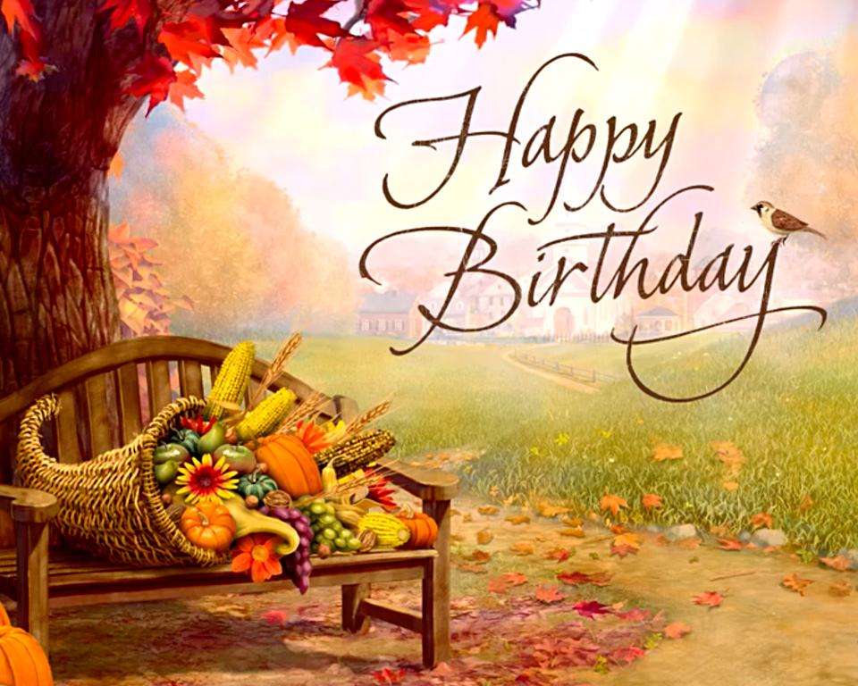

**Saint Hubert**

October 1 Sherry Blaisus

Angela Luna

October 5 Patricia Dubes

October 13 Linda Nudera

October 14 Ken Kelly

David Roof

October 16 Michael Miller

October 20 Sharon Beaudoin

October 21 Mike Wagster

October 23 Tim Kraft

**Saint James the Greater**

October 1 Lillian Prindle

October 2 Beverly Rose

October 3 Gerald Beckman

Leonard Natkowski

October 4 Karen Mayer

October 7 Lindsay Hillier

October 14 Carol Gottschling

October 20 Gail Klco

Kristy Muszynski

October 24 James Mikolaizik

Barbara Schlitz

October 25 Julianne Huff

October 26 Thomas Weingartz

October 27 Barbara Freebold

October 28 Charlotte Sredzinski

October 29 Lynne Frye

**Our Lady of the Lake**

October 2 George Everett

Allison Hood

October 5 Michael Mackey

Carol Spindler

Daniel Zielinski

October 7 Laurie Chudzinski

Timothy Cowan

Tyler Silva

October 8 Edmund Lipon

October 10 Michael Beech

Barbara Parol

Mary Speer

October 11 Louanne Vieau

October 15 Helga Chapp

October 16 Judy Moffit

October 17 Larry Respondek

Rodger Shutter

October 18 Celine Smith

October 19 Darren Barnes

Eugene Bowerman

Virginia Mulka

Pichard Polus

October 23 Barbara Stovall

October 24 Pamela Dugan

October 25 Gary Chapp

October 28 Charlotte Sredzinski

October 29 Madison Speer

October 31 Haleigh Foster

Mark Giasson

Patrick Torres