|  |  |
| --- | --- |
| October | 2025 |

|  |  |  |
| --- | --- | --- |
| Our Lady of the Lake, St. James, St. Hubert |  |  |
|  |  |  |

|  |  |  |  |  |  |  |
| --- | --- | --- | --- | --- | --- | --- |
| **Sunday** | **Monday** | **Tuesday** | **Wednesday** | **Thursday** | **Friday** | **Saturday** |
|  |  |  | 1 | 2 | 3 | 4 |
|  |  |  | 9:00 am Mass-OLL  9:00 am Mass-St. H  **5 hours of Adoration**  10 am - 3 pm OLL  **Confession**  11 am – 12 pm OLL  **Adult Faith Formation**  5:30 pm-OLL | 5:30 pm Mass-OLL  6:00 pm Mass-St. J | **First Friday Adoration**  9:00 am Mass-OLL  **Confessions**  10:00 am-OLL  9:00 am Mass- St. J | **First Saturday**  **9:00 am Mass-OLL**  **Confessions**  3:00 pm-OLL  **4:00 pm Mass-OLL**  **HS CCD**  5:15 pm-OLL  **Women’s Welcome Retreat** |
| 5 | 6 | 7 | 8 | 9 | 10 | 11 |
| **Confessions**  8:00 am-OLL  8:30 am-St. J  10:30 am-St. H  **9:00 am Mass-OLL**  **9:00 am Mass & Blessing of the Pets-St. J**  **11:00 am Mass & Blessing of the Pets-St. H**  **Student OCIA/FF**  **& Adult OCIA**  10:15 am-OLL  **Blessing of the Pets**  11:00 am-OLL  **Women’s Welcome Retreat** | 5:30 pm Mass-OLL  **Adoration**  6:00 pm OLL | 9:00 am Mass-OLL  6:00 pm Mass-St. H  **Book Study**  5:00 pm OLL | 9:00 am Mass-OLL  9:00 am Mass-St. H  **5 hours of Adoration**  10 am - 3 pm OLL  **Confession**  11 am – 12 pm OLL  **Ladies’ Card Club**  1:00-4:00 pm St. J  **Adult Faith Formation**  5:30 pm-OLL | 5:30 pm Mass-OLL  6:00 pm Mass-St. J  **Mass at King’s Nursing Home**  11:00 am  **CWC**  11:30 am-St. H | 9:00 am Mass-OLL  9:00 am Mass-St. J | 9:00 am Mass-OLL  **Confession**  3:00 pm OLL  **4:00 pm Mass-OLL**  **MS CCD**  5:15 pm-OLL |
| 12 | 13 | 14 | 15 | 16 | 17 | 18 |
| **Confessions**  8:00 am-OLL  8:30 am-St. J  10:30 am-St. H  **9:00 am Mass-OLL**  **9:00 am Mass-St. J**  **11:00 am Mass-St. H**  **Elementary CCD**  10:15 am-OLL | 5:30 pm Mass-OLL  **Adoration**  6:00 pm OLL | 9:00 am Mass-OLL  6:00 pm Mass-St. H  **Book Study**  5:00 pm OLL | 9:00 am Mass-OLL  9:00 am Mass-St. H  **5 hours of Adoration**  10 am - 3 pm OLL  **Confession**  11 am – 12 pm OLL  **Adult Faith Formation**  5:30 pm-OLL | 5:30 pm Mass-OLL  6:00 pm Mass-St. J  **Mass at the Brook**  11:00 am | 9:00 am Mass-OLL  9:00 am Mass-St. J | 9:00 am Mass-OLL  **Confession**  3:00 pm-OLL  **4:00 pm Mass-OLL**  **HS CCD**  5:15 pm-OLL  **Stargazer Gala-OLL** |
| 19 | 20 | 21 | 22 | 23 | 24 | 25 |
| **Confessions**  8:00 am-OLL  8:30 am-St. J  10:30 am-St. H  **9:00 am Youth Mass-OLL**  **9:00 am Mass-St. J**  **11:00 am Mass-St. H**  **Student OCIA/FF**  **& Adult OCIA**  10:15 am-OLL  **Euchre Party**  **12:30 pm-St. J** | 7:30 am Mass-OLL  **CCW Meeting**  3:30 pm OLL  **K of C**  7:00 pm St. J | 6:00 pm Mass-St. H  **Book Study**  5:00 pm OLL  **Men’s & Women’s Club**  5:30 pm-St. J | 9:00 am Mass-St. H  **Ladies’ Card Club**  1:00-4:00 pm St. J  **Adult Faith Formation**  5:30 pm-OLL | 6:00 pm Mass-St. J | 9:00 am Mass-St. J  5:30 pm Mass-OLL | 9:00 am Mass-OLL  **Confession**  3:00 pm-OLL  **4:00 pm Mass-OLL**  **St. Vincent Collection**  **MS CCD**  5:15 pm-OLL |
| 26 | 27 | 28 | 29 | 30 | 31 |  |
| **Confessions**  8:00 am-OLL  8:30 am-St. J  10:30 am-St. H  **9:00 am Mass-OLL**  **9:00 am Mass-St. J**  **11:00 am Mass-St. H**  **St. Vincent Collections**  **Elementary CCD**  10:15 am-OLL | 5:30 pm Mass-OLL  **Adoration**  6:00 pm OLL | 9:00 am Mass-OLL  6:00 pm Mass-St. H  **Book Study**  5:00 pm OLL | 9:00 am Mass-OLL  9:00 am Mass-St. H  **5 hours of Adoration**  10 am - 3 pm OLL  **Confession**  11 am – 12 pm OLL  **Adult Faith Formation**  5:30 pm-OLL | 5:30 pm Mass-OLL  6:00 pm Mass-St. J | 9:00 am Mass-St. J  **All Saints’ Vigil Mass**  5:30 pm-OLL |  |
| **Parish/School Office Hours:**  **Upcoming Events in November:**  November 2nd: All Souls’ Day  9:00 am Mass OLL (w/ candle lighting),  9:00 am Mass St. J, 11:00 Mass St. H  **OLL-Our Lady of the Lake**  **St. J- St. James**  **St. H- St. Hubert**  OLL Monday – Friday 8:00 am – 4:00 pm | | | | | | |

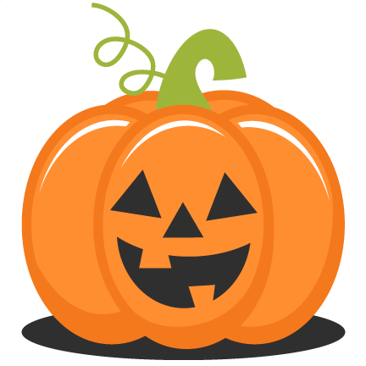 **October Birthdays** 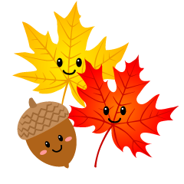

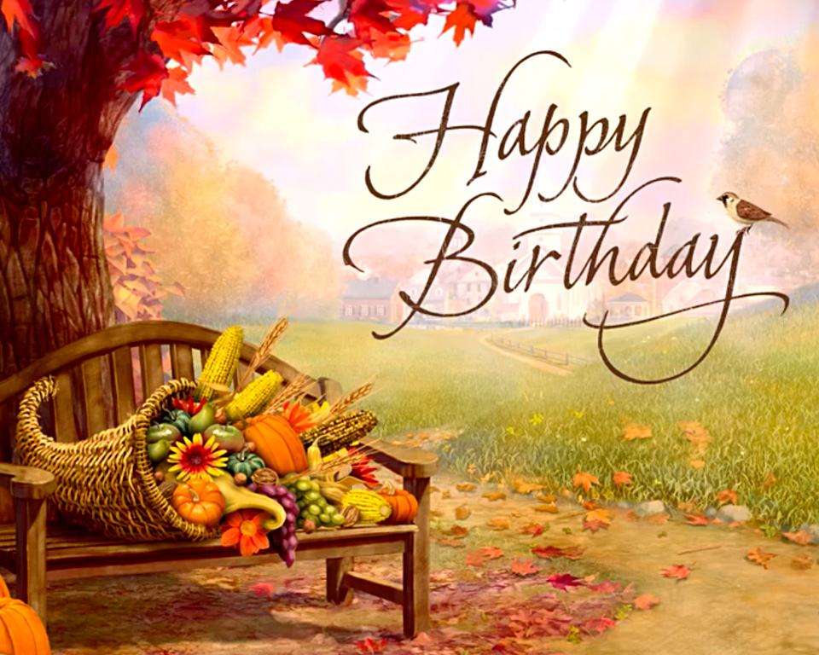

**Our Lady of the Lake**

October 2 George Everett

October 5 Michael Mackey

Carol Spindler

Daniel Zielinski

October 7 Laurie Chudzinski

Timothy Cowan

Tyler Silva

October 8 Edmund Lipon

October 10 Michael Beech

Barbara Parol

Meredith Poster

Mary Speer

October 11 Louanne Vieau

October 12 George Mika

October 14 Dorien Poster

October 15 Helga Chapp

October 16 Judy Moffit

October 17 Larry Respondek

Rodger Shutter

October 18 Celine Smith

October 19 Darren Barnes

Eugene Bowerman

Virginia Mulka

Pichard Polus

October 23 Barbara Stovall

October 24 Pamela Dugan

October 25 Gary Chapp

October 28 Charlotte Sredzinski

October 29 Madison Speer

October 31 Haleigh Foster

Mark Giasson

Patrick Torres

**Saint Hubert**

October 1 Sherry Blaisus

Angela Luna

October 5 Patricia Dubes

October 13 Linda Nudera

October 14 Ken Kelly

David Roof

October 16 Michael Miller

October 20 Sharon Beaudoin

October 21 Mike Wagster

October 23 Tim Kraft

**Saint James the Greater**

October 1 Lillian Prindle

October 2 Beverly Rose

October 3 Gerald Beckman

Leonard Natkowski

October 4 Karen Mayer

October 7 Lindsay Hillier

October 14 Carol Gottschling

October 20 Gail Klco

Kristy Muszynski

October 24 James Mikolaizik

Barbara Schlitz

October 25 Julianne Huff

October 26 Thomas Weingartz

October 27 Barbara Freebold

October 28 Charlotte Sredzinski

October 29 Lynne Frye