October | 2026

Our Lady of the Lake, St. James, St. Hubert
Sunday | Monday | Tuesday | Wednesday | Thursday | Friday | Saturday
 |  |  |  | 1 | 2 | 3
 |  |  |  | 5:00 pm Mass-St. J  5:30 pm Mass-OLL  Adoration  6:00 pm-OLL | 9:00 am Mass- St. J  9:00 am Mass-OLL  Adoration  9:30 am-OLL  Blessing of the Pets  2:30 pm-OLL | 9:00 am Mass-OLL  Confession  3:00 pm-OLL  4:00 pm Mass-OLL  Women’s Welcome Retreat  MS CCD  5:15 pm-OLL
4 | 5 | 6 | 7 | 8 | 9 | 10
Confession  8:00 am-OLL  9:00 am Mass-OLL  9:00 am Mass-St. J  11:00 am Mass-St. H  Adult OCIA  10:15 am-OLL  Women’s Welcome Retreat | 5:30 pm Mass-OLL  Adoration  6:00 pm-OLL | 9:00 am Mass-OLL  Adoration  9:30 am-OLL  5:00 pm Mass-St. H | 9:00 am Mass-OLL  9:00 am Mass-St. H  5 hours of Adoration  10 am - 3 pm OLL  Confession  11 am – 12 pm OLL | Mass at King’s Nursing Home  11:00 am  CWC  11:30 am-St. H  5:00 pm Mass-St. J  5:30 pm Mass-OLL  Adoration  6:00 pm-OLL | 9:00 am Mass- St. J  9:00 am Mass-OLL  Adoration  9:30 am-OLL | 9:00 am Mass-OLL  Confession  3:00 pm-OLL  4:00 pm Mass-OLL
11 | 12 | 13 | 14 | 15 | 16 | 17
Confession  8:00 am-OLL  9:00 am Mass-OLL  9:00 am Mass-St. J  11:00 am Mass-St. H  Elementary CCD  10:15 am-OLL | 5:30 pm Mass-OLL  Adoration  6:00 pm-OLL | 9:00 am Mass-OLL  Adoration  9:30 am-OLL  5:00 pm Mass-St. H  Men’s & Women’s Club  5:30 pm-St. J | 9:00 am Mass-OLL  9:00 am Mass-St. H  5 hours of Adoration  10 am - 3 pm OLL  Confession  11 am – 12 pm OLL  Ladies’ Card Club  1:00 pm-St. J | 5:00 pm Mass-St. J  5:30 pm Mass-OLL  Adoration  6:00 pm-OLL | 9:00 am Mass- St. J  9:00 am Mass-OLL  Adoration  9:30 am-OLL  Mass at the Brook  11:00 am | 9:00 am Mass-OLL  Confession  3:00 pm-OLL  4:00 pm Mass-OLL  MS CCD  5:15 pm-OLL
18 | 19 | 20 | 21 | 22 | 23 | 24
Confession  8:00 am-OLL  9:00 am Youth Mass-OLL  9:00 am Mass-St. J  11:00 am Mass-St. H  Adult OCIA  10:15 am-OLL  Euchre Party  1:15 pm-St. J | CCW Meeting  3:45 pm-OLL  5:30 pm Mass-OLL  Adoration  6:00 pm-OLL  K of C  7:00 pm-St. J | 9:00 am Mass-OLL  Adoration  9:30 am-OLL  5:00 pm Mass-St. H | 9:00 am Mass-OLL  9:00 am Mass-St. H  5 hours of Adoration  10 am - 3 pm OLL  Confession  11 am – 12 pm OLL | 5:00 pm Mass-St. J  5:30 pm Mass-OLL  Adoration  6:00 pm-OLL | 9:00 am Mass- St. J  9:00 am Mass-OLL  Adoration  9:30 am-OLL | 9:00 am Mass-OLL  Confession  3:00 pm-OLL  4:00 pm Mass-OLL  St. Vincent Collection
25 | 26 | 27 | 28 | 29 | 30 | 31
Confession  8:00 am-OLL  9:00 am Mass-OLL  9:00 am Mass-St. J  11:00 am Mass-St. H  St. Vincent Collections  Elementary CCD  10:15 am-OLL | 5:30 pm Mass-OLL  Adoration  6:00 pm-OLL | 9:00 am Mass-OLL  Adoration  9:30 am-OLL  5:00 pm Mass-St. H | 9:00 am Mass-OLL  9:00 am Mass-St. H  5 hours of Adoration  10 am - 3 pm OLL  Confession  11 am – 12 pm OLL  Ladies’ Card Club  1:00 pm-St. J | 5:00 pm Mass-St. J  5:30 pm Mass-OLL  Adoration  6:00 pm-OLL | 9:00 am Mass- St. J  9:00 am Mass-OLL  Adoration  9:30 am-OLL | 9:00 am Mass-OLL  Confession  3:00 pm-OLL  4:00 pm Mass-OLL  MS CCD  5:15 pm-OLL
Parish/School Office Hours:
OLL-Our Lady of the Lake
St. J- St. James
St. H- St. Hubert
OLL: Monday – Friday 8:00 am – 4:00 pm

October Birthdays
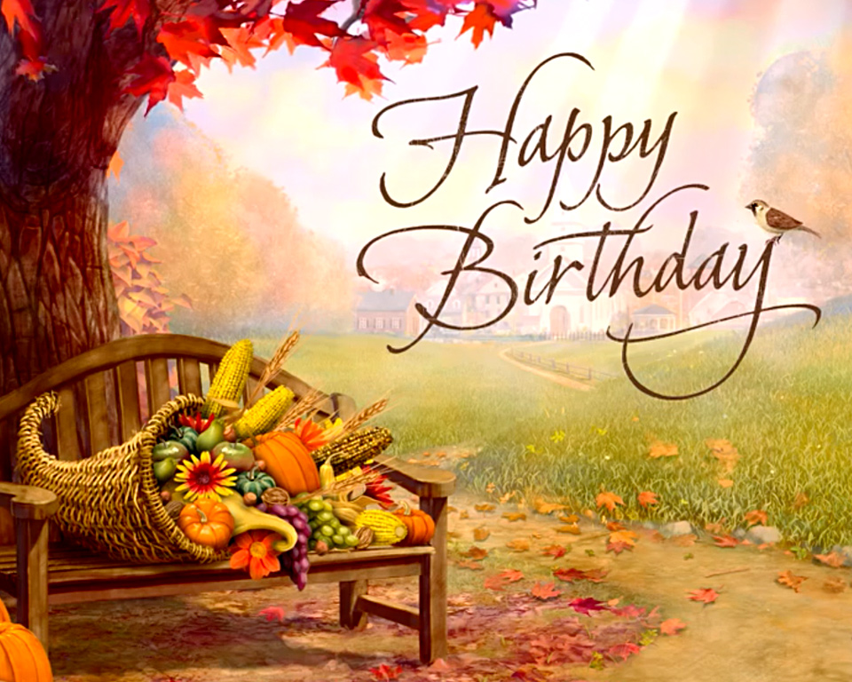
Our Lady of the Lake
October 1 Clay Kreiner
October 2 George Everett
October 5 Michael Mackey
Michael Newby
Carol Spindler
Daniel Zielinski
October 7 Laurie Chudzinski
Timothy Cowan
Tyler Silva
October 8 Edmund Lipon
October 10 Michael Beech
Barbara Parol
Meredith Poster
Mary Speer
October 11 Louanne Vieau
October 12 George Mika
October 14 Dorien Poster
October 15 Helga Chapp
October 16 Judy Moffit
October 18 Celine Smith
October 19 Darren Barnes
Eugene Bowerman
Virginia Mulka
Pichard Polus
October 23 Barbara Stovall
October 24 Pamela Dugan
October 25 Gary Chapp
October 28 Charlotte Sredzinski
October 29 Madison Speer
October 31 Haleigh Foster
Mark Giasson

Saint Hubert
October 1 Sherry Blaisus
Angela Luna
October 2 Genevieve Johnson
October 5 Patricia Dubes
October 13 Linda Nudera
October 14 Ken Kelly
David Roof
October 16 Michael Miller
October 20 Sharon Beaudoin
October 23 Tim Kraft

Saint James the Greater
October 1 Lillian Prindle
October 2 Beverly Rose
October 3 Gerald Beckman
Leonard Natkowski
October 4 Karen Mayer
October 7 Lindsay Hillier
October 14 Carol Gottschling
October 20 Gail Klco
Kristy Muszynski
October 24 James Mikolaizik
Barbara Schlitz
October 25 Julianne Huff
October 26 Kenneth Sohn
Thomas Weingartz
October 28 Charlotte Sredzinski
October 29 Lynne Frye

