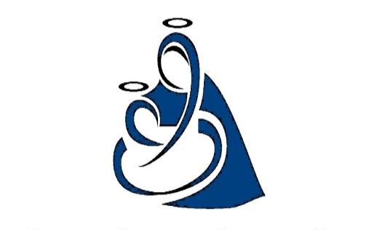
Our Lady of the Lake Regional Catholic School
Scholarship Application
2022/23

To be completed and signed by Parent/Guardian. One per family.

A legitimate form of income substantiation for the household from which each child resides must be included with this application. Acceptable forms include:

- 2021 Federal Income Tax Form 1040
- Official document verifying eligibility for welfare/and/or food stamps.
- Social Security Form 1099 or equivalent form verifying social security income.
- Unemployment income verification.
- Proof of loss of wages documentation (i.e. layoff notice)

List each student’s first name, last name and grade: (please print clearly)

1). __________________________________________ Grade: _______
2). __________________________________________ Grade: _______
3). __________________________________________ Grade: _______

Student Address:
_________________________________________________________________________
Address City Zip

Parent/Guardian/Financially Responsible Adult for each child. Please use additional
forms for multiple family situations. Annual income should reflect income from all sources; employment, child support, social security, etc. and include documentation.

(1): _______________________________ Annual Income: _____________________
Relationship to child: ________________________ Phone: _____________________
Address (if other than student):
_______________________________________________________________________
Address City Zip
(2): _______________________________ Annual Income: _____________________
Relationship to child: ________________________ Phone: _____________________
Address (if other than student):
_______________________________________________________________________
Address City Zip
Total number of dependent minors in household: _______
Total number of dependent adults in household: _______

Total Household Income for 2021 from all sources: $ ____________________________

I/We certify that the information contained on this application is correct and hereby grant Our Lady of the Lake Regional Catholic School Administration and/or its staff the right to view our income tax return for the tax year 2021 or other submitted documentation for the sole purpose of determining scholarship eligibility.

__________________________________ _______________________________
Signature of Parent/Guardian (1) Signature of Parent/Guardian (2)

