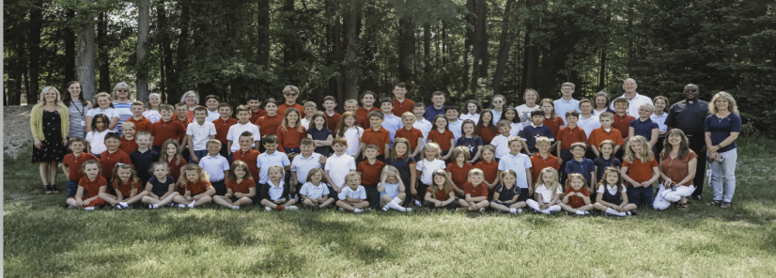
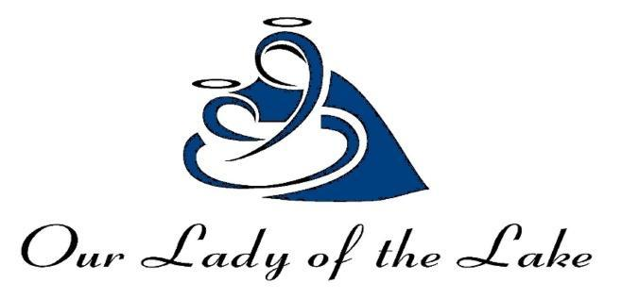
“Educate My Children” Catholic Education Fundraiser Donation Form

Please check one | Sponsorship Level | Acknowledgement  ***all online, social media and banner advertising acknowledgements will be for one full year.
 | Premier : $10,000 and above  Donation Amount: $ ____________ | Recognition in Parish Bulletin and Church monitor, Resorter, School Facebook and Website, banner in school gym and your business card on our new outdoor electronic sign for 4 months.
 | Gold: $5,000 - $9,999  Donation Amount: $ ____________ | Recognition in Parish Bulletin and Church monitor, Resorter, School Facebook and Website, banner in school gym and your name on our new outdoor electronic sign for a month.
 | Silver: $1,000 - $4999  Donation Amount: $ ____________ | Recognition in Parish Bulletin and Church monitor, Resorter, School Facebook and Website, and banner in school gym.
 | Bronze: $500 - $999  Donation Amount: $ ____________ | Recognition in Parish Bulletin and Church monitor, Resorter, and banner in school gym.
Other:

Donation Amount: $ ____________

 | I am not able to donate at this time, but will keep Our Lady of the Lake Regional Catholic School in my daily prayers.
Sponsor Information (please print)
Name:_________________________________________________________________________________

Address:_______________________________________________________________________________
(street address) (city, state, zip)
Phone: _______________________________________Email: ___________________________________
☐ I (We) would like our gift to remain anonymous.
Name of OLLRCS family to recognize for this donation:___________________________________________
Please return form with business card (if applicable) and make payments through QR code or checks payable to:
Our Lady of the Lake Regional Catholic School/OLLRCS 1039 W. Houghton Lake Dr. PO Box 800 Prudenville, MI 48651
