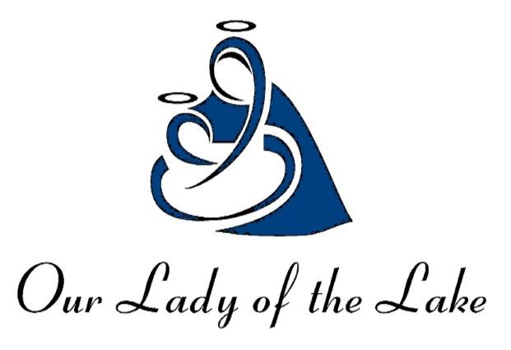
Our Lady of the Lake Church
Our Lady of the Lake Regional Catholic School
1037 West Houghton Lake Drive ~ PO Box 800
Prudenville, MI 48651

1-16-2024

Dear Parent/Guardian:

Our Lady of the Lake considers the health and well-being of our students and staff a priority. With that in mind, we are sending this letter home for your awareness. We have been alerted today that 2 individuals have been diagnosed with COVID-19. Individuals tested positive over the weekend and we do not feel anyone was in contact with the individuals prior to them testing positive. This is a courtesy letter for you to take precautions. We are following CDC recommendations to ensure that the person diagnosed with COVID-19 follows instructions for isolation and remains away from others until they can safely return to the school setting. We will also continue to clean and disinfect all areas of the school.

We recommend that you continue to monitor your child each day for symptoms. If your child develops COVID-19 symptoms, please:
- Contact their healthcare provider immediately.
- Follow testing and isolation instructions described by health department and the cdc
- Notify the school immediately, if they test positive for COVID-19.
We also encourage you to visit the local public health department’s website for additional information for ways to keep our school community safe.

We will continue to provide regular updates as needed and will provide prompt notification of any COVID-19 or other health-related concerns that require your attention. All COVID cases for OLLRCS students and staff are updated every day on our website. Please call us at 989-366-5592, or email us at ollsc@ollrcs.org if you have any further questions. We are committed to facilitating an optimal learning experience and ensuring the safety of our students and staff.

We thank the individuals that reported the COVID cases so that we were able to get word out to our OLLRCS community in efforts to keep everyone safe. Please join us in praying for our OLLRCS community that is suffering from COVID and/or feeling under the weather during this flu season.

Sincerely,

Michelle L. Johnson
OLLRCS Principal

