**Our Lady of the Lake Catholic Church**

**And Regional Catholic School**

1037W. Houghton Lake Dr. P.O. Box 800

Prudenville, MI. 48651 ~ (989) 366-5592

PRESCHOOL

HANDBOOK

**2025/2026**

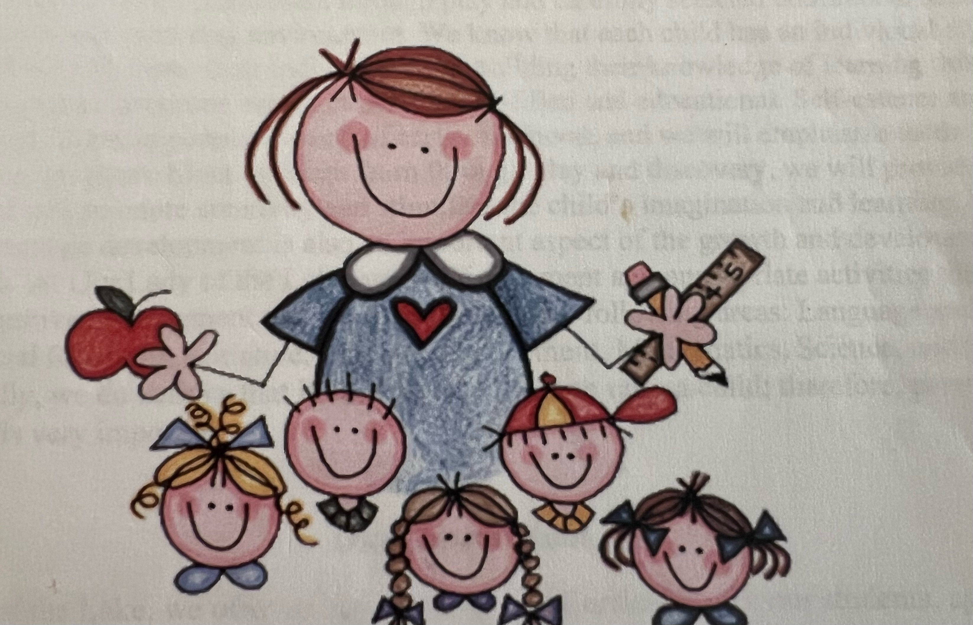

Mrs. Sara Finton & Ms. Anne Bawek - Teachers

State of Michigan Licensed Preschool