**Our Lady of the Lake Catholic Church**

**And Regional Catholic School**

1037W. Houghton Lake Dr. P.O. Box 800

Prudenville, MI. 48651 ~ (989) 366-5592

PRESCHOOL

HANDBOOK

**2025/2026**

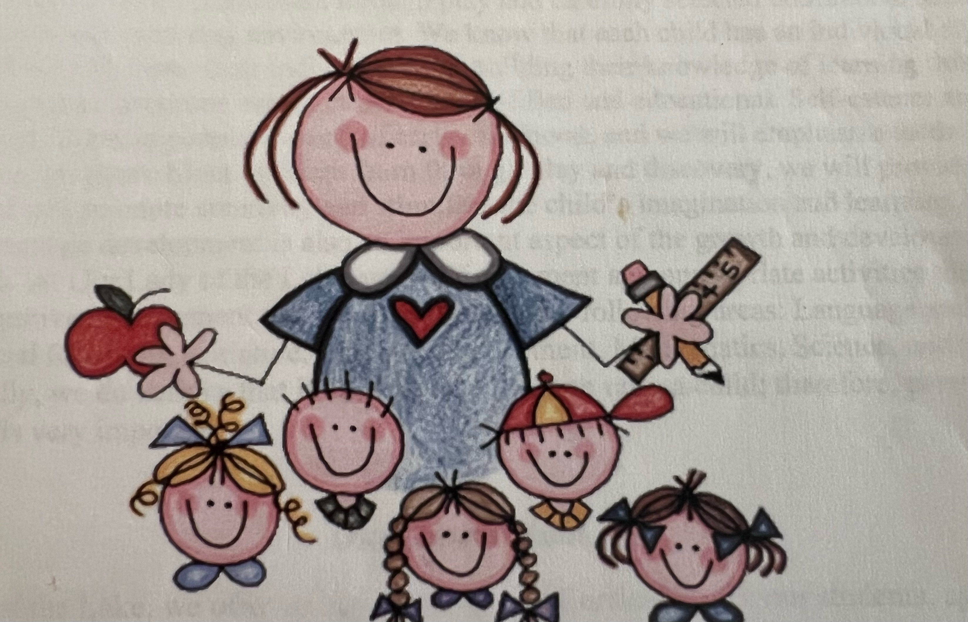

Mrs. Sara Finton & Ms. Anne Bawek - Teachers

State of Michigan Licensed Preschool

**Our Lady of the Lake Regional Catholic School**

**Preschool Program**

***Mission Statement***

***Nurturing minds, strengthening faith, fostering virtues***

Our Lady of the Lake Regional Catholic School unites with family and community to create a dynamic academic environment, rooted in the Eucharist and the Word, cultivating God-given talents.

**Our Philosophy**

Our Lady of the Lake Preschool Program believes that a child’s early years of development are vitally important. Children develop and learn through play and carefully selected educational activities in a safe, secure and nurturing environment. We believe that each child has an individual style of learning, and we will foster their individuality through observation and determining how each child learns best. Learning occurs through carefully selected age appropriate activities that are fun and educational. Self esteem and self reliance skills are also essential and are emphasized throughout our program. We provide materials which will promote creativity and stimulate imagination as the children learn through play and discovery. Language is also an important aspect of early childhood growth and development. At Our Lady of the Lake we will provide age appropriate activities to foster the students development and independence in language and literacy, social/emotional skills, music and movement, mathematics, science and social studies. Finally, we believe that it does take a village to raise a child, therefore, parent participation is very important.

***Our Curriculum***

Our preschool program at Our Lady of the Lake provides an age appropriate curriculum for children ages 3 yrs. 9 mos. to 5 years old and is designed to prepare them for kindergarten. Our curriculum is based on the views of Maria Montessori, which emphasizes independence and the development of the whole child, encompassing physical, social, emotional and cognitive development. It is designed for active learners and is very much a “hands & minds on” approach. This curriculum also fosters a partnership with our parents. Through it we will implement home and school connections which involve parents and invite open lines of communication. You will receive updates via a weekly or monthly newsletter outlining our themes and units of study. Each child will bring home a folder containing their daily work, which will also serve as an important tool for parent/teacher communication. Finally, any event or occurrence outside of the normal daily routine will be shared with parents at dismissal when you pick up your child

***Operating Policies***

1. A registration fee of $125.00 is required to accompany the completed registration forms. This is a non-refundable fee.
2. Tuition may be paid by check or money order in full for the school year, or you must use our FACTS portal. Please contact the school office at (989) 366-5592 for assistance in using the FACTS system.
3. All medications, whether prescription or over the counter remedies such as allergy medication, cough suppressants, etc. will only be administered by staff when instructed by the parents, and only if a medication form is filled out and signed. More information on this is given in the Illness Policy portion of this handbook.
4. Parents are to provide a healthy, ready to eat lunch. Pre-K students eat lunch in their classroom and staff will not have access to to a microwave for reheating food. Also, you are requested to provide anything the child will need to eat their lunch, such as a disposable spoon/fork, napkin etc. A drink should also be provided, or you may purchase milk. (Water is always available). Hot lunches are available for purchase on Wednesday through Friday through the FACTS portal. Please make sure to place hot lunch orders prior to nine a.m.
5. We require all preschoolers to have a complete change of clothes (socks, underwear & uniform) in a plastic bag, labeled with the child’s name. This clothing will remain in the their locker to be used if the need arises. If your child does not have a change of clothes and an accident or spill occurs you will be contacted to pick up your child. Keep in mind that we do wear uniforms, and most of the students clothes look the same. Therefore, Please help us out and make sure that all items are clearly labeled with your child’s name.
6. Our Lady of the Lake reserves the right to terminate enrollment if any child or parent becomes a discipline problem. The staff will work with the child/parent and attempt to reach a solution to the problem, however, if the situation persists beyond 30 days the child may be asked to leave. No tuition monies will be refunded.
7. During the first week of school parents will be allowed to walk their child down the hall to their locker and classroom if they choose. After that, we will have the child escorted down. During the month of September we realize that the children will have a period of adjustment and there may be tears. Be assured that in most cases the tears are short lived and a reassuring hug, followed by a quick goodbye is usually the best course. If a student is still struggling with coming to school after the first month the parents and school may have to reconsider if the child is ready for this setting.

***Closings and Delays***

**Emergency Closing:** Please be aware that OLLRCS will close or have a delayed start due to inclement weather based on the safety of the roads. We will put the safety of the children first. We will also be closed if any state or emergency is declared. Please tune in to TV 9 & 10 for information regarding school closures.

***Snack***

By mid-morning busy little learners are hungry and need something to keep them going until lunch. We ask that in addition to their lunch, you pack a healthy snack each day to keep their energy up and their minds ready to learn. Some good options are fresh fruits, veggies, yogurt, applesauce, string cheese etc. Please, no sweets or sugary snacks.

***Our Discipline Policy***

At our Lady of the Lake, we believe in teaching our students to use their words rather than hands by assisting them in solving their own problems. Our methods of guidance and discipline shall be positive, consistent with the developmental needs of the children, and applied with the full knowledge and understanding of the parents.

When inappropriate behavior occurs, it is interrupted and redirected with relevant feedback and guidance. Staff will model appropriate behavior and offer suggestions which will allow the children to actively participate in finding a solution. Using a relevant feedback approach, appropriate behaviors are emphasized and reinforced and the opportunity for misbehavior is minimized. Our policy provides for the following:

1.Staff will calmly address the situation.

2. Staff will allow students to discuss what happened.

3. Staff will then re-state the problem to clarify.

4. Staff will allow students to express their emotions, and will assist the child/children in finding a solution.

At no time will there be any use of hitting, corporal punishment, aggressive language, ridicule, harsh, humiliating or frightening treatment, or any kind of child abuse/neglect or exploitation. In extreme cases, for the safety of all the children, it may be necessary to remove a child from the group for a brief period of time. This will allow them time to regulate their emotions. A staff member will remain nearby and supervise the child at all times. No discipline shall involve or include the withholding of emotional response or stimulation and shall not require the child to remain silent or apart from the group for more than a brief period of time. (Usually 1 minute per year of child’s age). In cases of extreme or recurring discipline problems the enrollment of the child shall be reevaluated.

***Policy on the Management of Communicable Diseases***

If a child exhibits any of the following symptoms, he/she should not be at school. If such symptoms occur while at school, the child will be removed from the group, and you will be contacted to take him or her home. Symptoms include severe pain or discomfort, acute diarrhea, episode of acute vomiting, fever, sore throat, or severe coughing. Other symptoms for which a child must be excluded include yellow eyes or jaundice skin, red eyes with discharge, infected and untreated, skin patches, difficult or rapid breathing, skin lesions that are weeping or bleeding, swollen joints, visibly enlarged lymph nodes, stiff neck, or blood in the urine.

Once the child is symptom-free or has a doctors note stating that he/ she is no longer a health risk to himself or others he or she may return to school.

***Table of* Excludable *Communicable Diseases***

A child who contracts any of the following diseases may not return to school without a physicians note stating that the child presents no risk to him/herself or others:

Respiratory illness, - Gastrointestinal illness, - Contact illnesses. Chicken Pox** - Giardia Lamblia* - Impetigo - German Measles - Hepatitis A* - Lice - Hemophilus Influenza* - Salmonella* - Scabies. Measles* - Shigella* Meningococcus* - Mumps* - Strep Throat - Tuberculosis * -whooping Cough*

**Note:** Diseases noted with an asterisk above are reportable diseases that must be reported to the Health Department by the center.

*Parents/guardians please note: in order to administer any medication to your child, a doctors note and a signed medical release form, along with the labeled original container of medicine must be sent to school.*

***Illness Policy***

Communicable diseases can occur in any group, and we are no exception. Parents must make other arrangements for the care of their children when they show symptoms of any deviation from normal health. If a child becomes ill at school, the teacher or director will immediately notify the parents. The child will be kept comfortable and separated (under supervision) from the group until taken home. Staff, volunteers or children will not be permitted at our school with any of the following conditions:

1. Elevated temperature or any of the following: diarrhea, earache, signs of unusual, irritability, or confusion, sore throat, rash.
2. Vomiting on three or more occasions within the past 24 hours.
3. Diarrhea - three or more watery stools in a 24 hour period
4. Draining rash or undiagnosed rash lasting over a 24 hour period
5. Eye discharge or pink eye. Child can be readmitted after medical diagnosis to rule out bacterial or viral infection, or 24 hours of antibiotic treatment.
6. Open oozing, sores and scabs, unless properly covered, and 24 hours on an antibiotic treatment.

In case of minor injury or accident, the staff will administer basic first aid. All minor injuries or illness is not requiring immediate parental notification will be documented and reported to parents when the child is picked up at the end of the day. In case of medical injury, incident or illness requiring immediate professional care (emergency) the staff will call 911, giving the location and nature of the emergency. As appropriate, the staff will administer CPR or first aid measures. Parents will be notified immediately. If parents are unavailable, those individuals designated as emergency phone contacts will be notified. all children must have an emergency medical release form on file in case of such an emergency. In the case of an injury or accident in which 911 is not needed, but immediate professional care is required, the staff will contact the parents. If parents are not available, those individuals designated as emergency contacts will be notified. The staff cannot transport children to a hospital or doctors office. injured children shall be transported for medical aid by their parents or, if unavailable, by calling 911 for an ambulance. Children in the center are required to have a yearly physical examination. A copy must be kept on file at the school.

***Policy on the Release of Children***

Each child may be released only to the child’s parent(s) or persons authorized by the parents to take the child from the school. The authorized person assumes responsibility for the child in an emergency if the parent cannot be reached. If a non-custodial parent has been denied access or granted limited access to a child by a court order, the center shall secure documentation to that effect, maintain a copy on file, and comply with the terms of the court order. If the parent or persons authorized by the parent fails to pick up a child at the time of the centers daily closing, the center shall ensure that :

1. The child is supervised at all times,

2. Staff members will attempt to contact the parents or persons authorized by the parents.

3. If after one hour with no contact from a parent or authorized person, the supervising staff member will contact the police.

***Licensing***

Our Lady of the Lake Regional Catholic School Preschool Program is licensed by the State of Michigan Department of Human Services. As such, the program maintains a licensing notebook of all licensing inspection reports, special investigations, and all related correction action plans. The notebook is available for review by parents during regular school hours in the pre-K room. This notebook has all available information since May 28, 2010.

***Licensing inspection and special investigation reports from the past two years are available on the Bureau of Children and Adult Licensing website at*** [***www.michigan.gov/michildcare***](http://www.michigan.gov/michildcare)

***Emergency Procedures***

We take every potential emergency situation, very seriously. As a result, we have formulated the following procedures. Please review them with your family so that you are familiar with them in case of an emergency.

***Tornado***

These tornado procedures have been established and must be adhered to in every instance of a tornado. Tornado drills will be held a minimum of two times a year. In accordance with the instructions from our diocese of Gaylord, we devised this plan and designated the safest location within our building in the event of a tornado emergency. This location is in the hallway by student lockers with students in a turtle position.

1. We expect that parents are responsible for being aware of weather conditions. If a tornado watch or warning occurs, you may feel free to pick up your child.
2. Preschool will not be dismissed until all children have been picked up.
3. If weather conditions become threatening, or a tornado warning is issued, children will immediately, without delay be instructed by the teacher to quietly exit the classroom and go into the hallway. Children will be instructed to kneel down with their heads facing the wall, in a lowered position with their arms over their head to protect them from flying or falling objects. The teacher, with the emergency “go bag”, will direct the children and take cover in the hallway.
4. After all children are accounted for the teacher and staff assume the same position until the all clear is given.
5. Special accommodations will be made for students who have sensitive hearing by providing them with ear protection and a pre-warning of a scheduled drill. Any child with chronic medical conditions or mobility issues, will be moved with a wheelchair that the school has available.
6. The teacher and staff will reassure the children and make every effort to maintain calm and composure at all times. Once the children have all been accounted for the teacher will contact the parents by phone, keeping children together and releasing them only to their parents or other designated guardian as outlined in their enrollment forms.

***Fire emergency***

Fire drills will be held five times during the school year. Three drills will occur in the fall and two in the spring. All fire drills will be documented in the fire drill log which will be kept available in the main office of the school. Immediately upon discovery of any kind of fire in the building, or to initiate a fire drill, the fire alarm will be sounded. Upon hearing the fire alarm, staff members will immediately react as follows:

1. All children will be instructed to quietly form a single file line. The teacher closest to the outside door will take the children, along with the child information cards out through the closest approved exit.**(our designated meeting place is on the grass next to the large wooden statue of Mary.)** once at the meeting place, the teacher will instruct the children to stand quietly and proceed to take attendance.
2. If it becomes necessary to move farther away due to excessive heat, the fire department activities, or any other reason, all children will be moved through the front driveway to the former Dollar Daze lot directly to the west of OLL, or Gilroys Hardware to the east, and will be instructed to form a single file line. Once at the meeting place, the teacher will instruct the children to sit down quietly and proceed to take attendance. If after taking attendance, any child is not accounted for the fire department personnel will be advised of this immediately upon their arrival.
3. The teacher and staff will reassure the children and make every effort to maintain calm and composure at all times.
4. When all of the children have been accounted for the teacher will begin contacting the parents by phone, keeping children altogether, and releasing them only to their parents or other designated guardian as outlined in their child information card.
5. Special accommodations will be made for students who have sensitive hearing by providing them with with ear protection, and a pre-warning of any scheduled drill.

***Serious Accident or Illness***

In the event that any child is seriously injured or becomes seriously ill while in attendance at preschool, the following procedures will be followed:

1. The teacher will remain with the sick or injured child. Emergency first aid will be administered as necessary:
2. Check to ensure and maintain an open airway
3. Control any bleeding with direct pressure
4. Ensure proper circulation as necessary (CPR)
5. The **teacher** will reassure the child and keep him or her calm until the emergency medical personnel take over the child’s care.
6. The **teachers** **assistant** will immediately call 911 and report the emergency.
7. The **administrative assistant** will be responsible to make certain that all emergency medical personnel is directed to the sick or injured child.
8. A wheelchair will be used if the child cannot walk on their own. If the condition is any worse, the child will remain where they are until emergency medical assistance arrives. If the teacher has to accompany, the child to the hospital, the teachers assistant will remain in charge of the classroom along with the administrative assistant, who will assist her with the children until the teacher can return. Once the proper emergency medical personnel have been contacted, the parents of the sick or injured child will be immediately notified. If the conditions do not warrant immediate notification of emergency personnel, the parents will be contacted immediately to be notified of the situation. **In all emergency situations, parents will be contacted by the phone number provided by a staff member so children can be reunited with their families.**

***Bomb Threat***

In the event of a bomb threat, the person receiving the call will notify the program director or staff member in charge, who will immediately call 911 to report the bomb threat. Evacuation will immediately follow using the Fire Emergency Procedure.

***Other Natural or Man-Made Disasters***

In case of an earthquake or other natural disaster, the children will be directed to follow procedures established in the tornado drill. At the sound of the hyphenated buzzer, the children are to go out into the hallway and kneel down by the lockers with their heads on the floor and hands on top of their heads. The lead caregiver will assist any child with special needs. In the case of a man-made disaster, such as an oil spill or gas leak outside the building, the children will be directed to shelter in place. Once anyone remaining outside is brought in, the school will then go into lockdown mode. If the issue is inside the building, the children will be evacuated to Gilroys Hardware, or another location to be determined. The location will be chosen at the time, based on the location in the school building where the incident occurred. Any children with special needs will be assisted by the lead teacher.

**Note:** During any emergency, the teacher and staff will have the class list and emergency contact information with them at all times.

***Pick up and Custody Issues***

1. Any person who may pick up your child from school must be listed on the child’s information card. If an authorized person is new to us, we will ask to see a photo ID before releasing the child into their care.
2. In cases where custody or parenting time is at issue, please know that OLLRCS cannot keep a child from being released to a biological parent unless we have a copy of a court order on file. Any individual(s) who MAY NOT pick up the child should be written on the information card and marked with a highlighter. Again, we cannot withhold a child from a biological parent without a court order.

***Pesticide Policy***

In order to maintain Our Lady of the Lake Church and School, our facilities staff may have to utilize some form of pest control. If it is necessary to apply a pesticide, we will notify the families of students who will be in the affected areas 24 hours in advance of the application.

I have read the 2025/2026 OLRCS Preschool Handbook

(Please sign and return this page to school)

_______________________________________

Student Name (please print)

___________________________. _________________

Parent Signature Date

**Daily Schedule**

7:40 a.m. - early arrival / table play

8:00 a.m. - morning prayer and announcements in the gym

8:15 a.m. - show and share/ calendar/ circle time activities

8:30 - 9:00 - work time / handwriting

9:00 a.m. snack

9:15 - 10:15 - work time, centers & individual instruction

10:15- 10:45 - Religion (Mass each Wednesday @ 9:00 a.m.)

10:45 - bathroom breaks

10:50 - 11:15 - recess

11:20 - wash hands, prayer

11:25 -11:55 lunch

12:00 p.m. - 12:25 story and free play

12:30 - 1:00 - rest time

1:00 - 1:10 get up/ put mats away

1:10 - 1:20 number practice (wake up any sleeping children)

1:20 - 1:30 quiet free choice activities

1:40 - 2:00 recess

2:00 - drinks and bathroom breaks

2:05 - social studies/ science activities

2:30 - stories, music or big screen activity

2:45 - pack up and prepare for dismissal

3:00 - prayer and announcements

3:10 - Line up and go to the gym. Children are dismissed to parent

(This schedule will include a special each day. Days and times may vary. Special classes are library, gym, art and music. The entire student body will attend Mass each Wednesday at 9:00 a.m.)