MEMORIAL WOODEN BELL
A bell holds a special meaning within the Catholic faith. It is traditionally a call to prayer and worship, inviting us to pause and turn our hearts toward God. The sound of the church bell reminds us of God’s presence and calls us together for important moments in the life of the Church.

This Christmas season, our parish will use the Bell as a symbol of remembrance for the souls of the faithful departed. Each Memorial Bell will bear the name of a loved one who has passed away. As the bell calls us to prayer, may it also remind us of those we love and the hope we have in the promise of eternal life.

Throughout Advent and the Christmas season, Father Matthew will offer a daily prayer for all those remembered with a Memorial Bell. Starting on Saturday, December 12, 2026, continuing through the Epiphany (January 6, 2027), we will honor and commemorate our beloved dead in this special way, celebrating their light that now shines eternally in Christ.

You are invited to order a Memorial Bell in remembrance of a spouse, parent, child, grandparent, sibling, in-law, cousin, friend, or any loved one who has touched your life and has gone before you to God.
If you wish to take part, please complete the form below to dedicate a wooden Bell in their name (one person per bell).
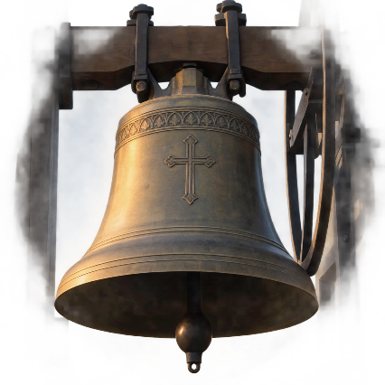
MEMORIAL BELL ORDER FORM

REQUESTED BY: ___________________________________________
PHONE NUMBER: __________________________________________

NAME(S) OF THE DECEASED: (please print clearly)

1______________________________________ 5______________________________________
2______________________________________ 6______________________________________
3______________________________________ 7______________________________________
4______________________________________ 8______________________________________
TOTAL NO. OF BELLS ORDERED: _____ x $5.00/each = TOTAL AMOUNT ENCLOSED: $____________
Checks can be made payable to Our Lady of the Lake Regional Catholic School (OLLRCS).

